

**Senior Design Project**

**THE DESIGN FOR A DEBRIS CLEARING VESSEL**

ENGE476 Senior Design Project I

Department of Engineering and Aviation Sciences

University of Maryland, Eastern Shore

Mohsin Mehmood

Hafeez Shittu

Project Advisor, Dr. Lei Zhang

Submitted

Mon. Day, Year

Special notice for formatting:

1. Don’t add any blank rows. Use spacing or page breaks.
2. Every figure or picture inserted in the text, must be accompanied with the caption and detailed description.
3. Keep the formatting consistent (learn and apply the MS ‘Styles’ in formatting).
4. The final report didn’t meet the basic formatting requirements won’t be accepted.

List of Contents

List of Contents 3

List of Figures 2

List of Tables 4

Abstract 5

1. Introduction 6

Backgound/Motivation 6

▪ Unwanted Migration: 6

▪ Chemical contamination: 6

▪ Marine mammals: 6

Objective 7

Design Requirements 7

Design Constraints 7

1. The main frame of the boat should be within 4ft * 3ft * 2ft (L*W*H). 7

2. Due to lack of funding, the overall budget for the design should be under 100$. 7

3. Limited Resources. 7

4. Easy to assemble. 7

Design Methods 8

2. Project Description 9

System Diagram 9

System Functions 10

3. Implementation Plan 11

Tasks 11

3.1.1 Task 1. Research Basic Boat design 11

3.1.2 Task 2. Preliminary boat design 11

3.1.3 Task 3. Weight Calculations 11

3.1.4 Task 4. Hydrostatic study 11

3.1.5 Task 5. Fluid dynamics 12

3.1.6 Task 6. CAD simulations 12

3.1.7 Task 7. Build a Prototype 12

3.1.8 Task 8. Image recognition system 12

3.1.9 Task 9. Navigation System 13

3.1.10 Task 10. Assemble the prototype 13

Team Organization 14

3.1.11 Responsibility of Team Member 1. 14

3.1.12 Responsibility of Team Member 2. 14

Timeline/Milestones/Delivery Plan 14

4. Implementation 15

Implementation of Task 1. 15

Implementation of Task 2. 18

Implementation of Task 3. 25

Implementation of Task 4 34

Implementation of Task 5 41

Implementation of Task 6 42

Static Analysis:1 54

Results: 77

Implementation of task 8 78

Implementation of task 9. 93

Implementation of task 10. 98

5. Conclusion. 98

Acknowledgement 99

Appendix 100

A. Component Specs 100

1. Specs of Arduino Due 100

2. Raspberry Pi 3 100

B. Source Code. 100

1. Source Code of Graphic User Interface 100

2. Source Code of Robotic Arm 100

REFERENCES 101

List of Figures

Figure 1 Connection between electronics 9

Figure 2 System Diagram: (a) Initial system, (b) Revised system 10

Figure 3 Banana Boat 16

Figure 4 Hydrofoil Boat 16

Figure 5 Catamaran boat 17

Figure 6 Pink foam Pontoon built 18

Figure 7 First design 19

Figure 8 Earlier design 2 19

Figure 9 Pontoon 20

Figure 10 3D earlier design 2 20

Figure 11 Earlier design 3 21

Figure 12 Collection box, mesh, Pontoon 21

Figure 13 Earlier design 3 22

Figure 14 Paddle wheel design 22

Figure 15 Solidworks Final design 23

Figure 16 PVC 24

Figure 17 Pink Foam 25

Figure 18 Volume of a rectangle 26

Figure 19 Buoyancy Principle 27

Figure 20 Height of un-displaced pontoon. 35

Figure 21 Center of mass cone 36

Figure 22 Half cylinder COM 37

Figure 23 Center of Buoyancy 38

Figure 24 COM, COB 39

Figure 25 COB 39

Figure 26 Metacenter 40

Figure 27 Stability of ship 41

Figure 28 Resistance in boat 42

Figure 29 Displaced part of vessel 43

Figure 30 Setting up wizard 43

Figure 31 Project setup menu 44

Figure 32 Drag Force 44

Figure 33 Flow analysis iteration chart 45

Figure 34 Absolute max 45

Figure 35 water flow around vessel 46

Figure 36 Flow trajectories 46

Figure 37 Flow trajectory 2 47

Figure 38 Fixed constraints 48

Figure 39 materials 49

Figure 40 Forces 50

Figure 41 Mesh settings 51

Figure 42 Pressure 51

Figure 43 Pressure 2 52

Figure 44 Result summary 53

Figure 45 Selected faces 56

Figure 46 Pressure 1 57

Figure 47 Pressure 2 58

Figure 48 Pressuer 2 59

Figure 49 Force 1 60

Figure 50 Force 1 61

Figure 51 Selected faces 62

Figure 52 Force 2 63

Figure 53 Selected faces 64

Figure 54 Selected faces fixture 65

Figure 55 Von Mises Stress 69

Figure 56 Min to Max Von mises stress 70

Figure 57 1st principle stress 71

Figure 58 Max and Min principle stress 72

Figure 59 3rd principle stress 73

Figure 60 Displacement 74

Figure 61 Max and Min Displacement 75

Figure 62 Displacement Max point 76

Figure 63 Safety Factor 77

Figure 64 pi graphic interface during update 79

Figure 65 overview 81

Figure 66 pictorial representation of CNN 82

Figure 67 neural network modification methods 83

Figure 68 edge detection 84

Figure 69 example for an inception neural network image processing 84

Figure 70 finding the error Figure 71 optimized process 85

Figure 72 installing tf 12.0 Figure 73 failed installation 86

Figure 74 successful installation 86

Figure 75 jypiter script tensorflow active 88

Figure 76 dataset 88

Figure 77 image labelling 89

Figure 78 file generated 89

Figure 79 label map 89

Figure 80 training interface 90

Figure 81 image recognition start up interface 91

Figure 82 successful trial 1 91

Figure 83 successful trial 2 92

Figure 84 2s battery Figure 85 image recognition set up 93

Figure 86 power connection layout for raspberry pi 93

Figure 87 pixhawk 94

Figure 88 mission planner interface 94

Figure 89 connection to mission planner through port 95

Figure 90 Select the right firmware 95

Figure 91 motor and servo control set up 96

Figure 92 navigation layout 97

Figure 93 power connection for microcontrollers 97

Figure 94 power connection for motors 98

List of Tables

Table 1 Total Volume table 35

Table 2 Total Mass table 35

Table 3 New Material property 37

Table 4 X, Y, Z coordinates 40

Table 5 Physical properties 56

Table 6 General objective 56

Table 7 Mesh settings 56

Table 8 Materials 58

Table 9 Force 1 61

Table 10 Force 2 63

Table 11 Bonds 69

Table 12 Reaction Forces 70

Table 13 Results 71

Abstract

The principle objective of this project is to design an autonomous marine vessel, use machine learning and target recognition to collect floating plastic bottles in a pond, lake and streams. The motivation behind this project is to find a cheaper and efficient solution for clearing certain water bodies (lakes, ponds, streams). By utilizing autonomous control, the vessel can operate freely and through machine learning, it can target plastic bottles and collect it. The mechanical design stages of any floating body consists of “Imagining and analyzing”, “Concept Design”, “Principle Design and GA drawings”, “CAD design and analysis”. The electrical design stages for components and control system consists of a 2 motors and their ESC, Raspberry pi3 to implement the intelligence, Pixhawk for the autonomous ability and the batteries to power the hold system. Most of the time in each task will be spend on research. Mechanical design will require the weight calculations, Hydrostatics study, Flow analysis, FEM analysis using a CAD software (Solid Works). This will further help improve our design. The goal for Mechanical design is to ensure the body will float and will be stable under applied force. The goal of the Electrical design is to create an environmentally friendly skimming tool which eliminated the use of fossil fuel as a source of energy. And although challenging, we aimed to effectively integrate the electrical hardware to the Artificial Intelligence neural network, in order to enable the grand system identify bottles then proceed for the collection.

1. Introduction

Here give a very brief explanation of what you are going to develop during the project with a few sentences.

## Backgound/Motivation

Plastic never goes away. And it's increasingly finding its way into [our oceans](http://www.biologicaldiversity.org/programs/oceans/index.html) and onto our beaches. In the Los Angeles area alone, 10 metric tons of plastic fragments — like grocery bags, straws and soda bottles — are carried into the Pacific Ocean every day. Today billions of pounds of plastic can be found in swirling convergences making up about 40 percent of the world's ocean surfaces. Plastic waste in lakes, ponds and smaller water bodies accumulate differently than plastic waste in oceans, Plastics can end up in a different place from where the plastic originated due to the pattern of lake currents. It is likely that some cities pollute more plastic than what ends up on their shores. Though plastics that enter a lake may disappear from view, much of the waste can be seen and has many effects on the lives around it. Some of the reasons for Plastic control in lakes and ponds is following:

* Unwanted Migration:

Migration has been in occurrence for as long as the existence of living things on the planet. Although migration is essential for survival, it has proven to be a major source of Biological pollution in man and animal. There is a variation in the immunity of animals, when animals migrate together to the same place, they are exposed to body fluid and waste of one another and to the genetically inferior species; contact with a wastage might lead to an explosion in illness or even death. A lot of animals are extinct due to biologically contamination due to MIGRATION.

* Chemical contamination:

When fertilizers and pesticides are used for Agricultural purposes, it exhibits the benefits of chemical advancements by improving yield but unfortunately, this chemicals are a major source of pollution. When rain falls, the fertilizers and pesticides are swept by flood into the water bodies and this has a detrimental effect on the aquatic animals and plant lives. When pesticides meant to kill off pests flow into the water body, they become harmful to the fishes in the lakes or ponds which might lead to death in aquatic life. Fertilizers that flow into the water bodies can increase the fertility of the water and cause a large growth of algae. This in turn creates a canopy on the water surface which deprives the plants and animals of sunlight and Oxygen.

* Marine mammals:

Marine mammals ingest and get tangled in plastic. Large amounts of plastic debris have been found in the habitat of endangered Hawaiian monk seals, including in areas that serve as pup nurseries. Entanglement deaths are severely undermining recovery efforts of this seal, which is already on the brink of extinction. Entanglement in plastic debris has also led to injury and mortality in the endangered Steller sea lion, with packing bands the most common entangling material. In 2008 two sperm whales were found stranded along the California coast with large amounts of fishing net scraps, rope and other plastic debris in their stomachs.

## Objective

The objective of this project is to design a Catamaran (Dual Hull) marine vessel capable of detecting 500 ml plastic bottles within 1 meter radius and collect them using machine learning.

## Design Requirements

The Design Requirements specified for this objective are as following:

1. The main frame of the vehicle should be able to support up to 60 lbs. of total load, including the Payload up to 20 lbs. and 25 lbs. of vehicle itself.
2. The motors should drive the vehicle with the velocity of 5 miles per hour.
3. The Design must be cost efficient.
4. Recognize floating plastic bottles using machine learning.
5. Should recognize the target (Volume 500ml, height 23.50cm, diameter 6.58, max weight .40g and function intelligently.
6. Based on the size of the collection chamber, the boat should be able to collect up to 35 empty water bottles.

## Design Constraints

In this system design, the design constraints are as following:

1. The main frame of the boat should be within 4ft * 3ft * 2ft (L*W*H).
2. Due to lack of funding, the overall budget for the design should be under 100$.
3. Limited Resources.
4. Easy to assemble.

## Design Methods

For this marine vessel, the design methods include mechanical and electrical design. First we will identify all the mechanical methods required and will be used in this design. The mechanical design methods are as following:

1. Project Description

In this section you are going to add more details of 'what' and answer the question 'how'.

System Description

The project is an integration of electrical and mechanical implementation. The simplified idea of the vessel is very similar to a boat. For propulsion will require 2 DC motors that would be selected based on a number of factors such as, energy consumption, water resistivity, rpm, torque and ability to withstand resistance from weight of debris. Those motors will be controlled by an Electronic Speed Controller (Esc). This regulates the amount of power supplied into the motors, it is the link between the motors, power supply and receiver or any micro- controller the signal is coming from and this system will make use of 2 microcontrollers. In this system, we are implementing 2 concepts which executes the smartness and the autonomy. The Pixhawk which is the primary controller of the system will be microcontroller responsible for autonomous motion and this will be executed by setting wave points or paths to follow by using a software called the mission planner. The second micro controller is the raspberry pi2, and it is the micro controller responsible for implementing the intelligence aspect of the system by analyzing images or video captured through the use of a camera.

1. Implementation Plan

## Tasks

The design methods used in this process are converted into main tasks and their sub-tasks. Since this is a group project, there will be tasks based on mechanical design and then the electrical designs. They are as following:

### Task 1. Research Basic Boat design

#### Subtask 1. Research

The first main subtask is to research various boat designs and how they work.

#### Subtask 2. Identify suitable boat design

The second subtask is to identify a design based on research.

### Task 2. Preliminary boat design

#### Subtask 1. Hand drawings

Draw basic design which was identified using Task 1. Come up with different designs to choose from.

#### Subtask 2. Compare and contrast

Compare and contrast all the designs. Learn about their Pros and Cons, Based on that choose the most efficient design.

### Task 3. Weight Calculations

#### Subtask 1. Calculate volume

Calculate the volume of each part so we can calculate the mass of each part and then the whole system.

#### Subtask 2. Calculate Mass

Calculate the mass using the volume from subtask 1 and each parts material density.

### Task 4. Hydrostatic study

#### Subtask 1. Calculate Buoyancy force

Use the volume, mass to calculate the buoyant force of the floating ship.

#### Subtask 2. Calculate center of buoyancy

Use the area submerged to find the center of the buoyant force

Subtask 3. Calculate Displacement

Calculate the volume of the water displaced.

#### Subtask 4. Calculate center of mass

Identify and calculate the center of mass of the whole system

#### Subtask 5. Calculate meta centric height

Find the metacentric height based on the COM and COB

#### Subtask 6. Calculate stability

Identify the stability of the ship using the angles 0-15 degrees to ensure the boat will not tip over and the system will be stable.

### Task 5. Fluid dynamics

#### Subtask 1. Calculate drag

Calculate the drag of the ship in fluid.

#### Subtask 2. Calculate lift

Calculate the lift of the ship in fluid.

### Task 6. CAD simulations

#### Subtask 1. Flow analysis

Simulate the boat in fluid using computer aided design software, In this case we will use Solid-works.

#### Subtask 2. FEA Stress analysis

Simulate the boat stress analysis to identify if the system will fail or not.

### Task 7. Build a Prototype

#### Subtask 1. Order the components

#### Subtask 2. Build the boat

### Task 8. Image recognition system

#### Subtask 1. Set up the image recognition API

Involves the configuration of the raspberry pi microcontroller, installing all dependencies required to perform target recognition

#### Subtask 2. Research on CNN

Involves comprehending how a convolution works, building, manipulating and training a network. Also involves selecting the best model for this process

#### Subtask 3. Training the model

The training of the neural network with our dataset

#### Subtask 4. Result

Uploading our trained model into the raspberry pi and testing to get results

#### Subtask 5. Runtime of the system

Obtain how long the recognition system can be in operation based on the power supply

### Task 9. Navigation System

#### Subtask 1. Research on Pixhawk configuration

Look into how a pixhawk works and how it can be configured to adapt to sailing

#### Subtask 2. Layout of the Navigation system

Deliver a pictorial representation of the system to aid adequate comprehension, explaining the communication pattern between the raspberry pi and pixhaewk

#### Subtask 3. Runtime of the whole system

Broke the power system into 2 and found the run time and each power source.

### Task 10. Assemble the prototype

#### Subtask 1. Connection

Connect all the components together and run tests

#### Subtask 2. Build the boat

Aid my partner in building the boat

## Team Organization

As identified before this project is split into two equal parts: Mechanical design and the electrical design. The mechanical design will be the responsibility of team member 1 and the electrical design will be the responsibility of Team member 2.

### Responsibility of Team Member 1.

Responsibilities of Team member 1 are as following:

* Task 1
* Task 2
* Task 3
* Task 4
* Task 5
* Task 6
* Task 7

### Responsibility of Team Member 2.

* Task 8
* Task 9
* Task 10

## Timeline/Milestones/Delivery Plan

Please prospect the timeline to deliver the results of each task/subtask.

Please schedule your project to no more than 22 weeks from now.

1. **Project Timeline and Delivery Plan**

|  |  |  |  |
| --- | --- | --- | --- |
| Time | Task | Comments | Responsible Personnel |
| Week 1-4 | Choosing topics | Week 1 through 4 were spent looking for the topic. | Mohsin Mehmood, Hafeez Shittu |
| Week 5 | Finish task .11  Started subtask 8.3 | Research                             Setting up the API | Mohsin Mehmood  Hafeez Shittu |
| Week 6 | Finish Subtask 1.2  Finished subtask 8.1 | Identify suitable boat design  Setting up the API | Mohsin Mehmood  Hafeez Shittu |
| Week 7 | Finish Subtask 2.1  Started subtask 8.1 | Hand drawings  Training the model | Mohsin Mehmood  Hafeez Shittu |
| Week 8 | Started Subtask 2.2  Finished subtask 8.5 | Compare and contrast  Runtime for the raspberry pi3 | Mohsin Mehmood  Hafeez Shittu |
| Week 9-11 | Finished Subtask 3.1,3.2,3  Finished  8.4, 8.3. | Calculate volume, mass, displacement  Training the model /Results | Mohsin Mehmood  Hafeez Shittu |
| Week  12-15 | Finished Subtask 4.1-4.6  Started subtask 9.1 | Calculate displacement, center of mass, MC height, stability  Research on Pixhawk configuration | Mohsin Mehmood  Hafeez Shittu |
| Week 16 | Finished Subtask 5.1,5.2  Finished Subtask 9.1 | Calculate drag and lift  Research on Pixhawk configuration | Mohsin Mehmood  Hafeez Shittu |
| Week 17 | Finish Subtask 6.1  Finish Subtask 9.2 | Flow analysis  Layout of the navigation system | Mohsin  Hafeez |
| Week 18- | Finish subtask 6.2  Finish Subtask 9.3 | Fem analysis  Runtime of the whole system | Mohsin  Hafeez |
| Week 19-32 |  |  |  |

1. Implementation

## Implementation of Task 1.

Research:

When it comes to boat, there are countless ways to design it. This is based on the functions of the boat it-self. So, the first step for this subtask was to research and understand what different types of boats are capable of and which design is most suitable based on our design requirements.

“A boat is a small vessel which has been specifically designed for navigating in near-shore areas or inland waterways.” Though there is a thin line between a ship and a boat, t[here are quite a few differences which set both of them apart.](https://www.marineinsight.com/types-of-ships/7-differences-between-a-ship-and-a-boat/) Boats can be classified into three main sections as follows:

1. Unpowered or man-powered (like rafts, gondolas, kayaks, etc.),
2. Sailboats (sail-propelled)
3. and Motorboats (engine-powered)

Since, we wanted our vessel to move slowly through the water, i was able to shrink the boats to research from drastically. The boat designs considered are as following:

## 

Banana Boats

As the name suggests, it is banana-shaped and inflatable and easily floats on water. It does not have an inbuilt motor system. A banana boat has a capacity to seat around three to ten people.

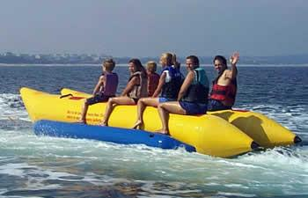

Figure 3 Banana Boat

The reason for this design consideration was its ability to carry heavy payloads. With the addition of right electrical motors we can turn this passenger boat design into a debris collecting vessel.

Hydrofoil boats:

The hydrofoil system incorporates the use of wings or lifts (Pontoons) to raise the boat from the surface of the water and move forward.

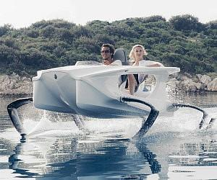

Figure 4 Hydrofoil Boat

The reason for this design consideration was solely because of the empty cavity in the front, which we can incorporate into the collection bin for the vessel.

Catamaran Boats:

According to the Google Definition: “A catamaran (/ˌkætəməˈræn/) (informally, a "cat") is a [multi-hulled](https://en.wikipedia.org/wiki/Multihull) [watercraft](https://en.wikipedia.org/wiki/Watercraft) featuring two parallel [hulls](https://en.wikipedia.org/wiki/Hull_(watercraft)) of equal size. It is a geometry-stabilized craft, deriving its stability from its wide [beam](https://en.wikipedia.org/wiki/Beam_(nautical)),”

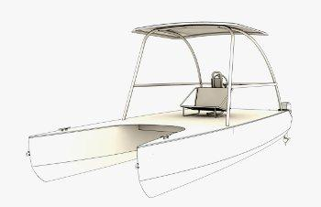

Figure 5 Catamaran boat

The stability is mainly due to equal sized hull on each sides. The catamaran boat with three hulls is also plausible in real life, but for our design purpose, we need to focus on two hull catamaran design.

Pontoons and its advantages:

Due to our design requirement of collection of at least 25 pounds, i used pontoon boat design for our vessel due to its many advantages. Some of the advantages are as following:

Ease of Use/Maintenance

Pontoons can be made from any light materials. Aluminum is the ideal material used for industrial pontoons. We are planning to use Pink insulation foam to build our pontoons, this is then be reinforced using fiberglass sheets and Epoxy resin. Working with Pink foam is easy and it’s very easy to maintain.

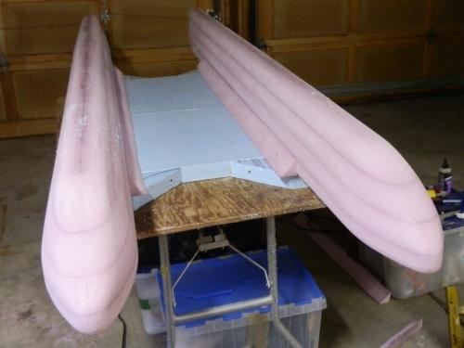

Figure 6 Pink foam Pontoon built

Longevity:

This is one of the most important factor for using pontoons. Pontoons built using Pink foam can last longer and is very easy to maintain. The boat can be left in water for a long period of time can still function without any problems.

Building Cost and Storage:

Building cost for pontoons using pink foam is very low, 80 dollars to be exact. This includes the Pink foam, epoxy resins, Fiberglass sheets. Pontoon boats are also known for their storage capabilities. Due to certain design requirements, using pontoons will provide us empty area which will function as the collection bin.

## Implementation of Task 2.

Earlier designs:

To start the project, we started with the major component of the build, that would be task 1 (Subtask 1). This Subtask includes a rough 3-D diagram of the parts of the system, as well as the whole 3-D design of the vessel, itself. Working on the rough design means, we have to identify all the dimensions, Size and Materials which meet the design requirements one way or the other.

Doing the Subtask 1 was the hardest part in this project, that’s because every-time I proposed a design, I got criticized. Here are some of the earlier designs below:

First design:

The first design for the boat was poorly hand sketched based on mine and my partner’s idea, most of the later and final design follow the same pattern of design. The first design is the figure below:

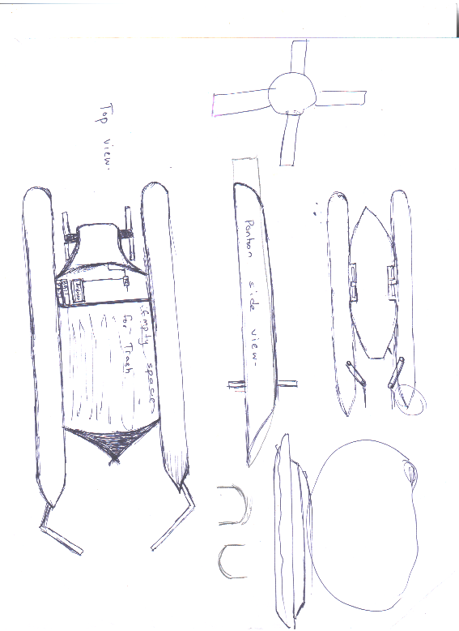

Figure 7 First design

Earlier design 2:

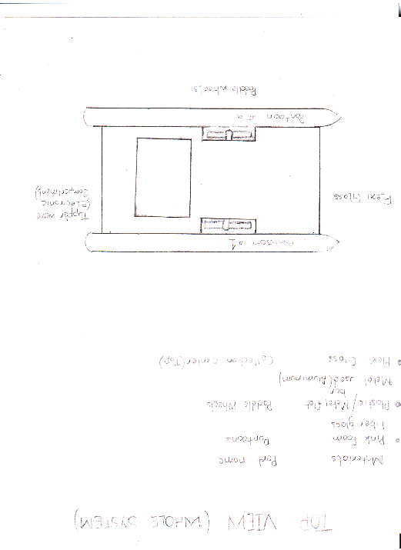

Figure 8 Earlier design 2

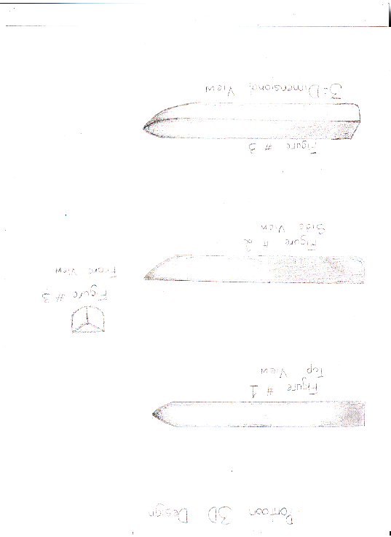

Figure 9 Pontoon

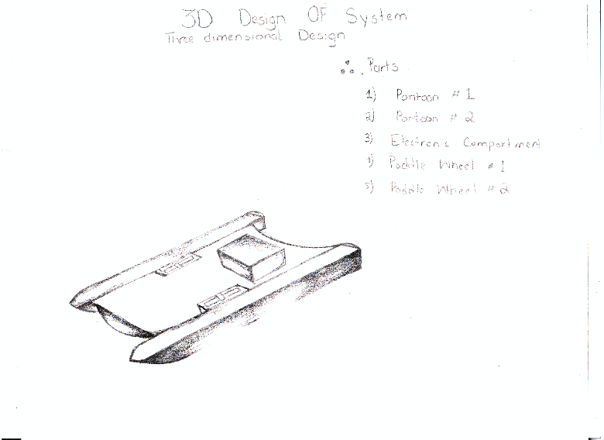

Figure 10 3D earlier design 2

Cons for Earlier design 2:

The first design seems to meet all but two design requirements which are as following:

1: Lack of storage:

Due to lack of storage space, we identified that this design cannot hold more than 16.6 pound of weight.

2: Shallow ends collection:

The second reason for this design failure was its inability to collect debris from the shallow ends which is one of the most important design requirements.

Earlier Design 3:

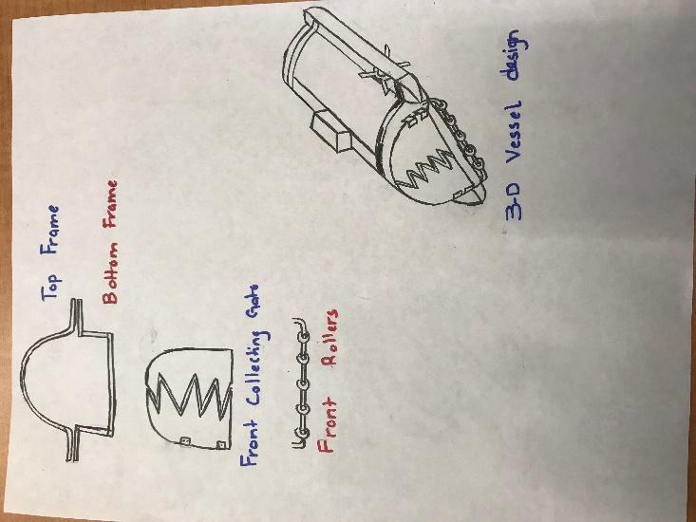

Figure 11 Earlier design 3

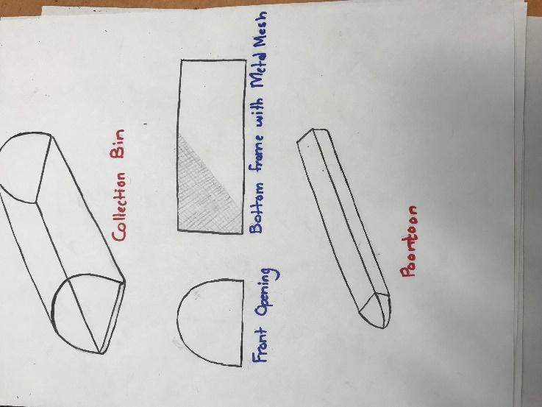

Figure 12 Collection box, mesh, Pontoon

**Cons for earlier design 3:**

In my opinion, this was a valid design and met all the design requirements, but due to constant pressure from my partner and instructor, the design was completely changed. The argument against this design “it’s too close to a boat design, design something innovative.”

**Earlier design #3**

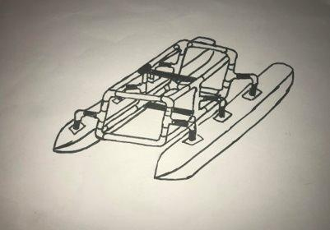

Figure 13 Earlier design 3

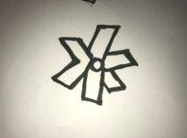

Figure 14 Paddle wheel design

Based on all the research and continuous trial and error, i was able to come up with a final design, which followed all the design requirements, it was also approved by the instructor himself.

Cons for “Earlier Design 3”

The design has to be evaluated and after evaluating this design i realized it won’t be efficient.

Pros for “Earlier Design 3”

The pros for the final design are as following:

1: The frame is very light.

2: The pontoons are also very light.

3: This is cost-efficient.

4: The parts can be re-assembled for storage.

5: Malleable parts.

Final Design:

Below are some images to show the new boat design.

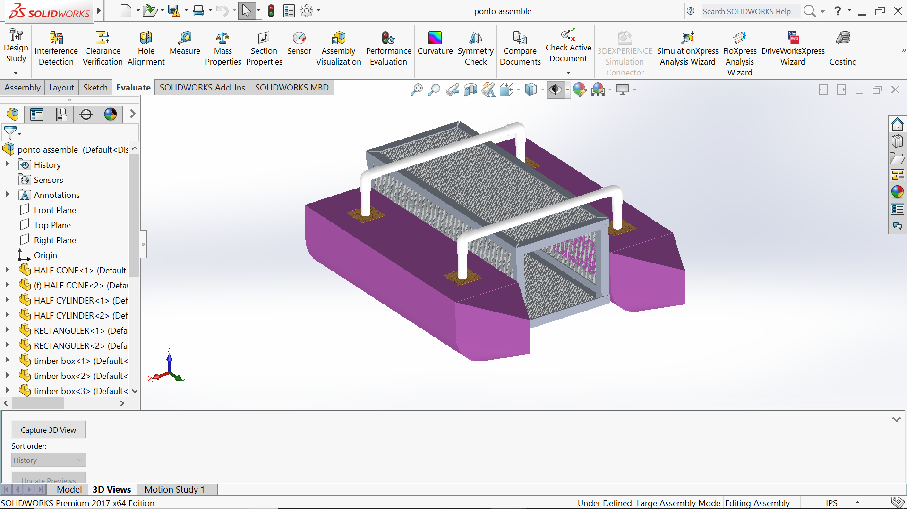

Figure 15 Solidworks Final design

This part required research on the best possible materials that can be used for this built. The following are the characteristics for the materials we can use:

1: Light-Weight:

The material should be lightweight, this will cover the design requirement for ease of use. The light weight implies that less force is required to move this vessel around.

2: Strength:

Strength is a big factor when considering materials as well, since the vessel should be able to hole 25 pounds or more of debris without the system sinking. This also causes a problem since many light materials are not strong.

3: Cost efficient:

The material we use have to be cost efficient, since this product is to save money and lower expenses.

4: Ease of access:

Since, we are university student, we also had to make sure that the materials we use can easily be found in local hardware stores.

Materials:

Based on all the factors above i was able to identify the following materials:

1: PVC Pipes:

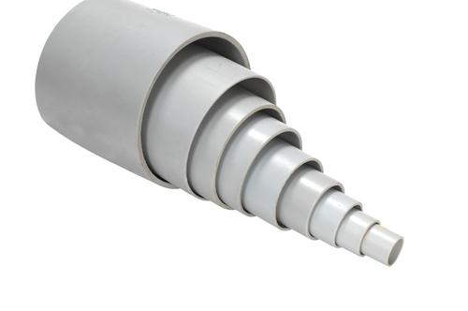

Figure 16 PVC

Pros:

The pros for using PVC pipes are following:

1: Superior corrosion resistance

2: Cheap

3: Good heat resistance

4: Strength

5: High pressure resistance

6: Inert to most mineral acids, bases and salts.

7: Ease of access

8: Choice of size

Pink Foam:

Pink foam or Polyurethane panels are what we will use to build the pontoons of the vessel:

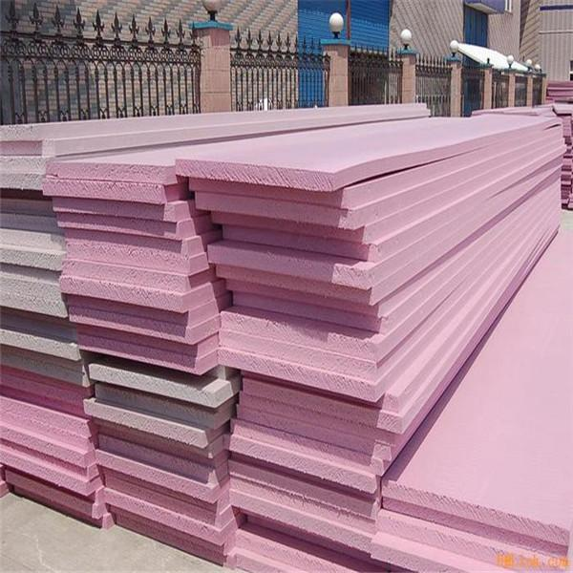

Figure 17 Pink Foam

Pros for Pink foam:

Some of the pros of using Pink foam are as following:

1: Thermal conductivity

2: Moisture sensitivity

3: Compressive strength

4: Ease of installation

5: Durability - resistance to degradation from compression, moisture, decomposition, etc.

6: Ease of replacement at end of life

7: Cost effectiveness

## Implementation of Task 3.

In order to approach this task we must identify the formulas used:

Formulas Used:

Different shapes have different volume formulas. We used the ones following to find volume for each part of the boat.

1: Rectangular prism

We used this to find volume for rectangular parts of pontoon.

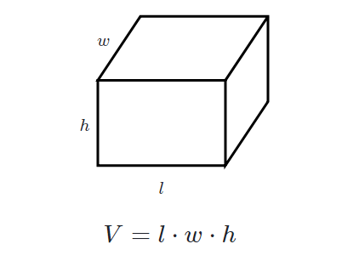

Figure 18 Volume of a rectangle

2: Triangular Prism

This was used to find the volume for front part of pontoon.

3: Cylinder

This was used to find the half cylinder shape of the pontoon.

4: Cone

This was used to find the front conic volume for pontoon.

Density Formula:

Formulas used:​

* Density = Mass / Volume​

Or​

* d = M / V​
* Volume of Cylinder: Pi * r^2 * h

Key-Terms​

* P = represents density
* m = represents mass
* v = represents volume

This formula is used to identify individual mass.

Finding Buoyant force:

The name of this upward force exerted on objects submerged in fluids is called the buoyant force. So why do fluids exert an upward buoyant force on submerged objects? It has to do with differences in pressure between the bottom of the submerged object and the top. Because pressure exerted increases as you go deeper in a fluid, the force from pressure exerted downward on the top of the body will be less than the force from pressure exerted upward on the bottom of the body. That is why the buoyant force is necessary for a boat design:

$$(Fb=rho gh)$$

$$Buoyant force = ρgV​$$

Where:​

ρ is the density of the fluid​

g is the gravitational acceleration​

V is the volume of the fluid displaced

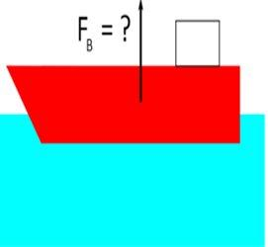

Figure 19 Buoyancy Principle

* Density of water = $62.42796529 lb/ft^3 >> 999.992061 kg/m^3$

​
* g = 9.81 m/s^2​

Finding volume and mass for each part:

Half Cylinder:

Radius of half cylinder = 0.10160m

Density of foam = 21 kg/m^3

Height of the Half cylinder = 0.7154m

Volume of Half cylinder = ($pi*r^{2}*h)/2$

(3.14 * (0.1016^2) * 0.7154) / 2

= 0.011 m^3

To calculate for two cylinders = $Volume of 1 cylinder * 2$

= $(0.011m^3 * 2)$

= 0.022 m^3

Mass of one cylinder = Volume * Density

Density of Pink insulation foam = 21 kg/m^3

$$= 0.01153*21$$

= 0.24213 kg

To calculate mass for two cylinders = $Mass of 1 cylinder *2$

$$=0.24213*2$$

= .48426 kg

Front cone half Volume and Mass:

This includes the two half conic sections and the triangular sections on the pontoon.

Total volume = Volume of half cone + Volume of triangular pieces

>> Half cone Volume

Radius = 0.101m

Height + 0.203m

Volume of a half cone = $(\frac{1}{6}*(3.14)*{(0.101}^{2})*(0.203))$

= $1.083 *{10}^{-3} m^{3}$

>> Triangular pieces

Volume of Triangle $= (Area of triangle * Height)$

$$=((B*H*L)/2)$$

= (0.203 * 0.203 * 0.101) / 2

= $2.08*{10}^{-3} m^{3}$

Volume for two of each piece since there are two pontoons.

= $\left(\left(1.083*{10}^{-3}\right)+\left(2.08*{10}^{-3}\right)\right)*2$

= $0.00632 m^{3}$

Mass calculation for the above pieces = Volume * density

$$=\left(3.16*{10}^{-3}\right)*21$$

= 0.06636 kg

Mass for two of each part in consideration = $0.06636*2$

= 0.13272 kg

Wooden Cubes

>> Volume of outer cube

Volume = L * B * H

= 0.076 * 0.076 * 0.076

= $4.38*{10}^{-4} m^{3}$

>> Volume of Inner circle

Volume = $π*r^{2}*h$

$$=3.14*{0.0125}^{2}*0.025$$

= $9.81*{10}^{-5}$

Total volume = $\left(4.38*{10}^{-4}\right)-\left(9.81*{10}^{-5}\right)$

= $\left(3.39*{10}^{-4}\right)*2$

= $0.00678 m^{3}$

Mass = v*d

= $3.39*{10}^{-4}*680$

= 0.23052 kg

For 4 wooden cubes=

= 0.23052*4

= 0.92208 kg

Rectangular Blocks * 2

>>Volume

L*b*h = 0.711*0.203*0.101

=0.0145 m^3

Total volume= {volume of rectangular blocks – (volume of 2 3*3*3 blocks)} *2

= $0.145-\left(4.38*{10}^{-4}\right)*2$

=0.0272m^3

Weight = (0.0136*21)*2

=0.2856kg * 2

=0.5712kg

PVC pipes 18.5 inches*2/ 4 inches*4

Volume/mass for 18.5 inches:

$$V=pi \left(R^{2}-r^{2}\right)*h$$

$$=3.14*\left({0.0125}^{2}-{0.011}^{2}\right)*0.4699$$

$$=5.20*{10}^{-}5 m^{3}$$

So, to calculate the volume for 2 18.5 inch PVC pipes $=\left(5.20 * {10}^{-5}\right)*2$

= $0.000104 m^{3}$

>> Mass Calculation (18.5 inch PVC)

Using Density equation = $5.20*{10}^{-5}*1300$

= 0.0676 kg

For two PVC pipes (18.5 inch)

= 0.0676 * 2

= 0.1352kg

>> Volume for PVC (4 inches)

Volume = $π\left(R^{2}-r^{2}\right)*h$

$$=3.14\left({0.0125}^{2}-{0.011}^{2}\right)*0.101$$

$$=1.117*{10}^{-3}{ m}^{3}$$

For 4 pieces = $(1.117*{10}^{-3} m^{3}*4$

$$=0.004468 m^{3}$$

>> Mass Calculation (4 inch)

Mass = $1.117*{10}^{-3}*1300$

$$=0.0145 kg$$

For 4 Pieces = (0.0145 * 4)

= 0.058 kg

Elbow PVC Volume and mass calculation

>> Volume Calculation

Volume = $2*3.14*3.14\left(r^{2}-r_{1}^{2}\right)*R$

r = outer ring radius

$$r_{1}= inner ring radius$$

R = radius of curvature

$$=2*3.14*3.14\left({\left(14.5*{10}^{-3}\right)}^{2}\right)-{\left(12.5*{10}^{-3}\right)}^{2})*14.5*10^-3$$

$$=1.54*{10}^{-5}m^{3}$$

For 4 Pieces of PVC elbows = (1.54 *10^-5 m^3)*4

$$=0.0000616 m^{3}$$

>> Mass Calculations (PVC Elbow)

Mass

= $\left(1.54*{10}^{-5}\right)*\left(1300\right)$

=0.02002 kg

For 4 PVC elbows =

= 0.02002 * 4

= 0.08008 kg

Volume and Mass Calculations (Aluminum Angle bar 28 inches)

>>Volume Calculations

Volume = $\left(l_{1}*b_{1}*h_{1}\right)+\left(l_{2}*b_{2}*h_{2}\right)$

= $\left(0.03*3.18*{10}^{-32}*0.7\right)+\left(0.02*3.18*{10}^{-3}*0.7\right)$

$$=1.113*{10}^{-4} m^{3}$$

For 4*28 inches aluminum angle bar = $\left(1.113*{10}^{-4}\right)*4$

$$=0.0004452 m^{3}$$

>> Mass Calculations

Mass = Volume * Density

$$=\left(1.113*{10}^{-4}\right)\left(2700\right)$$

= 0.030051 kg

For 4 * 28 inches Aluminum angle bars

= 0.030051 kg * 4

= 0.120204 kg

Volume and Mass Calculations for Aluminum angle bar (12 inches)

>> Volume Calculations

$$Volume= \left(l_{1}*b_{1}*h_{1}\right)+\left(l_{2}*b_{2}*h_{2}\right)$$

$$=\left(0.03*3.18*{10}^{-3}\right)+\left(22.23*{10}^{-3}*0.3*3.18*{10}^{-3}\right)$$

$$=4.98*{10}^{-5}m^{3}$$

For four 28 inches aluminum angle bars =

$=4.98*{10}^{-5}m^{3}$*4

= $0.0001992 m^{3}$

>> Mass Calculations

Mass = ($4.98*{10}^{-5})*(2700)$

= 0.134 kg

For four 28 inches aluminum angle bars

$$=0.134*4$$

= 0.538 kg

Mass and Volume calculations For Box aluminum bars

>> Volume Calculations

Volume = Volume of outer cube – Volume of inner cube

$$=\left(l_{1}*b_{1}*h_{1}\right)-\left(l_{2}*b_{2}*h_{2}\right)$$

$$=\left(\left(25.4*{10}^{-3}*2504*{10}^{-3}*247.6*{10}^{-3}\right)-\left(19.05*{10}^{-3}*19.05*{10}^{-3}*247.6*{10}^{-3}\right)\right)$$

$$=0.069*{10}^{-3} m^{3}$$

For 4 pieces

$$=0.069*{10}^{-3}*4$$

= $0.000276 m^{3}$

>> Mass Calculations

Mass

= $0.069*{10}^{-3}*2700$

= 0.188 kg

For four pieces = 0.188 kg *4

= 0.752 kg

Volume and Mass calculations for Aluminum Mesh

>> Volume calculations

Total volume = Volume of whole body – Volume of displaced holes

$$={\left(25.4*{10}^{3}\right)}^{2}*\left(2.54*{10}^{-3}\right)-\left(1.524*{10}^{3}\right)*100$$

= $1.04*{10}^{-6}m^{3}$

>>Mass Calculations

Mass = $1.04*{10}^{-6}*1016$

= 2.85 kg

Mass Calculations for the screws

Standard weight for the screws used = 0.00585 kg

For 20 screws

= 0.00585 * 20

= 0.0117 kg

Total volume Table

|  |  |
| --- | --- |
| **Parts** | **Volume** |
| Half Cylinder | $$0.48426 m^{3}$$ |
| Front Cone | $$0.00632 m^{3}$$ |
| Wooden Cubes | $$0.000678 m^{3}$$ |
| Rectangular blocks | $$0.0272 m^{3}$$ |
| PVC 18.5 inch | $$0.000104 m^{3}$$ |
| PVC 4 inch | $$0.004468 m^{3}$$ |
| PVC Elbow | $$0.0000616 m^{3}$$ |
| Aluminum Angle Bar 28 inch | $$0.0004452 m^{3}$$ |
| Aluminum Angle Bar 12 inch | $$0.0001992 m^{3}$$ |
| Aluminum Box Bar 12 inch | $$0.000276 m^{3}$$ |
| Aluminum Mesh | $$1.04*{10}^{-6} m^{3}$$ |
| **Total Volume** | $$0.5241304 m^{3}$$ |

Table 1 Total Volume table

**Total mass Table**

|  |  |
| --- | --- |
| **Parts** | **Mass** |
| Half Cylinder | 0.48426 kg |
| Front Cone | 0.13272 kg |
| Wooden Cubes | 0.92208 kg |
| Rectangular blocks | 0.5712 kg |
| PVC 18.5 inch | 0.1352 kg |
| PVC 4 inch | 0.058 kg |
| PVC Elbow | 0.08008 kg |
| Aluminum Angle Bar 28 inch | 0.120204 kg |
| Aluminum Angle Bar 12 inch | 0.538 kg |
| Aluminum Box Bar 12 inch | 0.752 kg |
| Aluminum Mesh | 2.85 kg |
| Screws | 0.117 kg |
| **Total Mass** | 6.760744 kg |

Table 2 Total Mass table

## Implementation of Task 4

Mass breakdown of the ship:

Total weight of the building materials = 6.760744 kg =>14.8736368 pounds

The mass of electronics = 10.17 pounds

Maximum Mass of the payload = 25 pounds

Total weight of the boat including dead weight and payload weight = 50 pounds => 22.72727 kg

Total Water Displacement

$$Total mass =22.72727kg$$

$$v =\frac{22.72727}{1000}$$

$$v =2.272727×{10}^{-2}m^{3}$$

Volume of Boat Base Parts







$$Volume of the semi-cylindrical parts$$

$$Volume of the cone shaped parts$$

$$Total bottom part$$

Total water displacement should be 0.0227 cubic meters.

But, 0.0227<V1+V2. Hence, both cylindrical and conical parts are not fully submerged in water due to the 22.727 kg weight.

$$Volume of excessively displaced water=0.025394-0.0227=0.002667 cubic meters$$

>> If height of excessively displaced water is h,









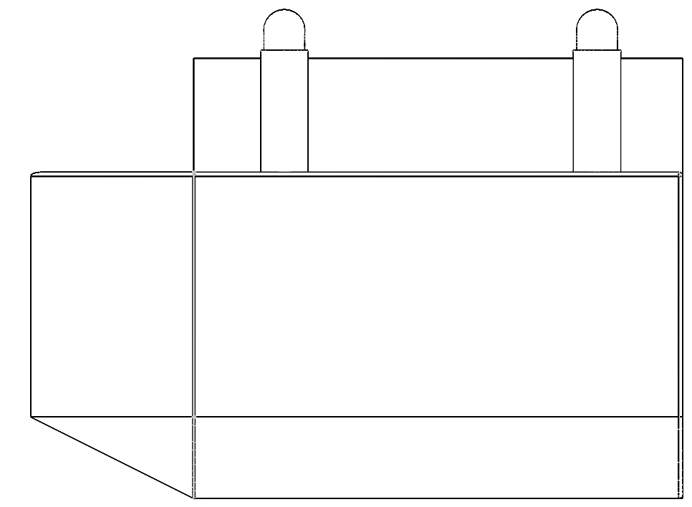

**0.109 meters**

Figure 20 Height of un-displaced pontoon.

Mass and Floating Properties

There are several materials used in boat components. But due to lack of options in Solidworks and Inventor, I had to change some materials and the new materials chosen are below:

|  |  |  |
| --- | --- | --- |
| **Part** | **Material** | **Density (lbs-inch-3)** |
| **Base** | Styrofoam | 0.001301 |
| **Connecting tubes** | PVC | 0.050578 |
| **Container** | Aluminum Plates + Mesh | 0.097544 |
| **Top Mesh** | Aluminum Plates + Mesh | 0.097543 |

Table 3 New Material property

Center of mass

Since the density of the Styrofoam is extremely low whereas the volume of the PVC parts is negligible, one can assume that the center of mass of the boat is the one of the container.

The distance between the center of mass of semicircle and the center of mass of the respective circle is the following:

.

One can calculate the x and z coordinates of the center of mass of the cone part as follows

 

Where,

.

Hence,

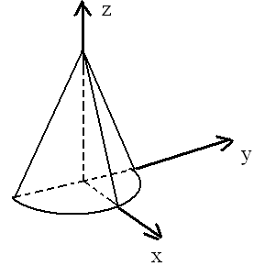

Figure 21 Center of mass cone

In the case of the semi-cylinder, the coordinates of the center of mass are the following:

m, , meters.

Since h<<0.1016 m, one can assume that the center of the mass of the part of the semi-cylinder that is not submerged has such the coordinates m, m, and. Hence, for the coordinates of the center of mass of the submerged part of the cone, one can write the following:

,, and  where  and . Hence, m and m.

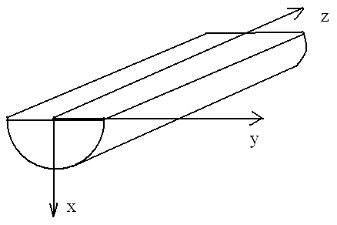

Figure 22 Half cylinder COM

Center of buoyancy

Assuming that the coordinate origin is chosen on the top edge of the bottom part as shown below, one can calculate the coordinates of the center of the buoyancy as follows

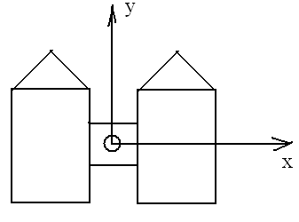

Figure 23 Center of Buoyancy

|  |  |  |  |  |
| --- | --- | --- | --- | --- |
| Part | , cubic meters | , meters | , meters | , meters |
| Left semi-cone | 0.000931 | -0.1396 | 0.4295 | -0.0389 |
| Right semi-cone | 0.000931 | 0.1396 | 0.4295 | -0.0389 |
| Left semi-cylinder | 0.01043 | -0.1396 | 0 | -0.0475 |
| Right semi-cylinder | 0.01043 | 0.1396 | 0 | -0.0475 |
| Center of the buoyancy |  | 0 | 0.035203 | -0.0468 |
|  |  |  |  |  |

Table 4 X, Y, Z coordinates

The location of the center of mass (COM) and the center of buoyancy (COB) is shown below:

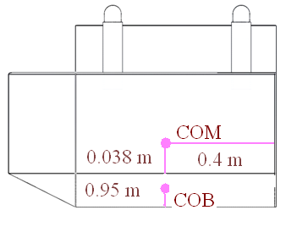

Figure 24 COM, COB

The metacentric radius is the distance between COB and the metacenter. It equals  where  is the second moment of area of the water plane section with respect to the y axis (see the illustration below). As for, it is the total water displacement and equals 0.0227 cubic meters. One can calculate the value of I as follows

.

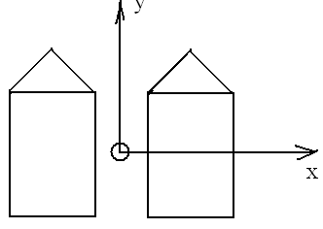

Figure 25 COB

Hence, the metacentric radius equals = 0.336 meters. Since the metacentric height is the distance between the metacenter and COM, it is equal to 0.251 m.

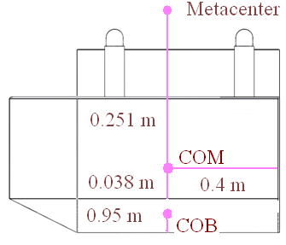

Figure 26 Metacenter

The moment due to the movement of the load equals  where  is the displacement of the load and M is the load mass. Since the load mass equals the one of the boat, th moment due to the shift of the center of mass equals . Hence, the displacement of the load s that corresponds to the tilt angle  has such the value . Thus, if  ranges from 0 to 15°, then the load displacement ranges from 0 m to 0.131 m.

Stability of the boat

On Figure 1,, M, G, B, and  are respectively the angle of a heel, the metacenter, the center of gravity, the center of buoyance when , and the center of buoyance when the angle of a heel equals . The stability curve is the plot of the dependence  (see Figure 1). For small values of, one can assert that. In the case in hand,.

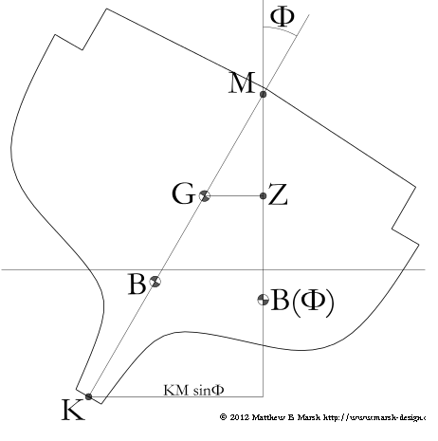

Figure 27 Stability of ship

## Implementation of Task 5

As we finish with the hydrostatic evaluation of the design, we will move on to finding out the Drag and Lift forces that will be applied to the design while moving at the velocity of 5mph.

This will compute the fluid dynamics of the design.

>> Drag and lift forces

Since the velocity is very small, the flow is the creeping one. Therefore, one can assert that the shape of the boat is streamlined. Hence, the pressure drag vanishes. As for the viscous drag, one usually ignores it calculating the speed of the boat. Hence, the drag force equals zero.

On Figure 2, the hydrodynamic side force is the lift. From Figure 2, it follows that under the condition of the zero drag, the directions of the apprent wind and the true one coinside and are opposite to the boat course. Hence, from the symmetry considerations, it follows that the lift equals 0 too.

But since Evaluating Drag and lift force is an important part of designing a marine vessel, solidworks was used to evaluate drag and lift forces.

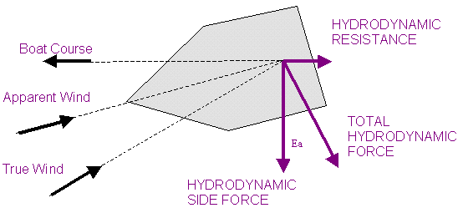

Figure 28 Resistance in boat

## Implementation of Task 6

Task 6 contains two main subtasks, which are:

1: Flow simulation

According to Solidworks: “SOLIDWORKS Flow Simulation. Engineering Fluid Dynamics (EFD) is a new breed of Computational Fluid Dynamics (CFD) software that enables mechanical engineers to simulate fluid flow and heat transfer applications with powerful, intuitive, and accessible 3D tools.”

2: FEA stress analysis.

Stress analysis helps us compute our virtual design’s structural analysis, it is used to find the products real world physical behavior.

Earlier plans:

At first, only one computer aided design software was going to be used in order to do both FEA and flow simulation. That software is Solidworks. The outdated version 2012 was our only choice, before I bought 2017 Solidworks. The designing of the vessel in Solidworks was simple but time consuming. Most of all, many systems which I used to run the said software couldn’t handle the memory usage. After one month of trial and error I was able to run flow simulation.

Setting up Flow Simulation:

All flow simulation steps used for this project are as following:

**1: Cut Section and set up wizard:**

First step was to cut the vessel assembly right on the computed waterline. This helps us not only lower the run time but it also helps us focus on only the submerged parts of the vessel.

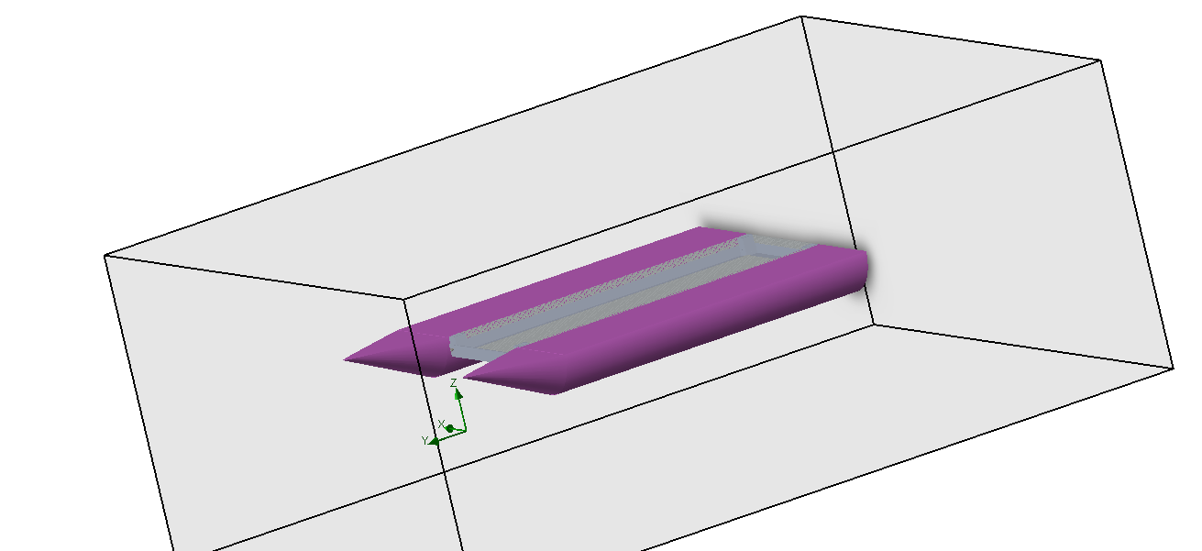

Figure 29 Displaced part of vessel

One the body is cut at the water line, setup the wizard for flow simulation, while setting up the wizard, you can apply any kind of liquids, gases that are present in the library. Also during this setup Wizard is when you apply the velocity of the vessel which it will be moving under water in.

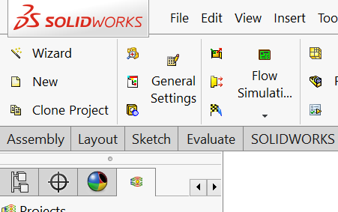

Figure 30 Setting up wizard

**Project setup:**

Once the Solidworks flow simulation wizard is complete, the next step is to focus on the Project settings, this includes computational domain setup, fluid subdomain setup, Boundary conditions setup, Goals setup and lastly mesh setup:

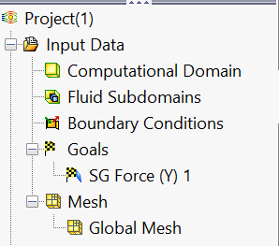

Figure 31 Project setup menu

After is setup my computational domain, which included all the cut through body submerged, I moved onto providing this project it’s unique boundary conditions such as buoyancy force, etc. These values were calculated before.

Soon after I set up the goal to find all forces on the conic face of the vessel, this is in-fact our drag force which is being applied to the front of the vessel while it moves at 5 miles per hour.

All the conditions set, we ran the simulation and results are as following:

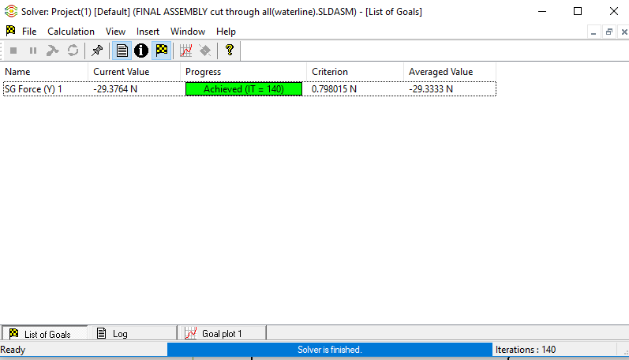

Figure 32 Drag Force

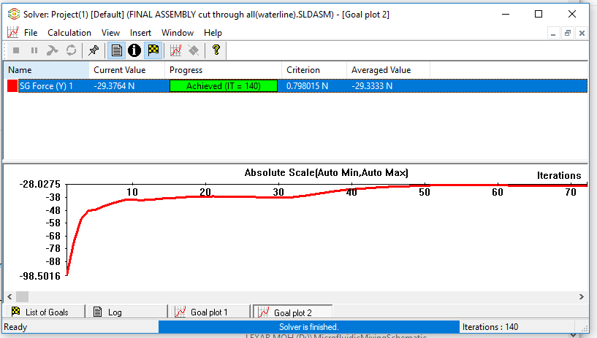

Figure 33 Flow analysis iteration chart

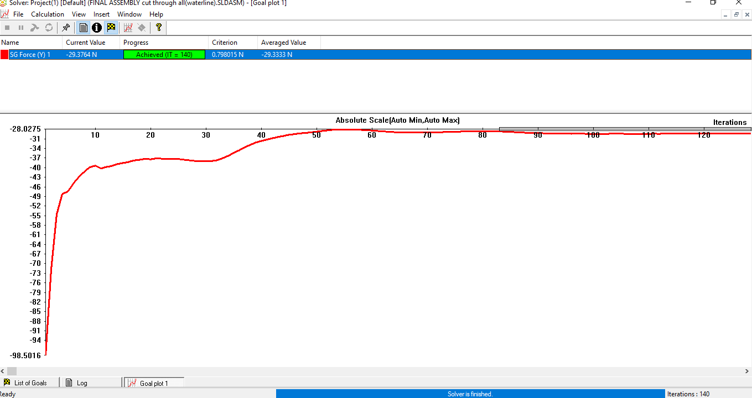

Figure 34 Absolute max

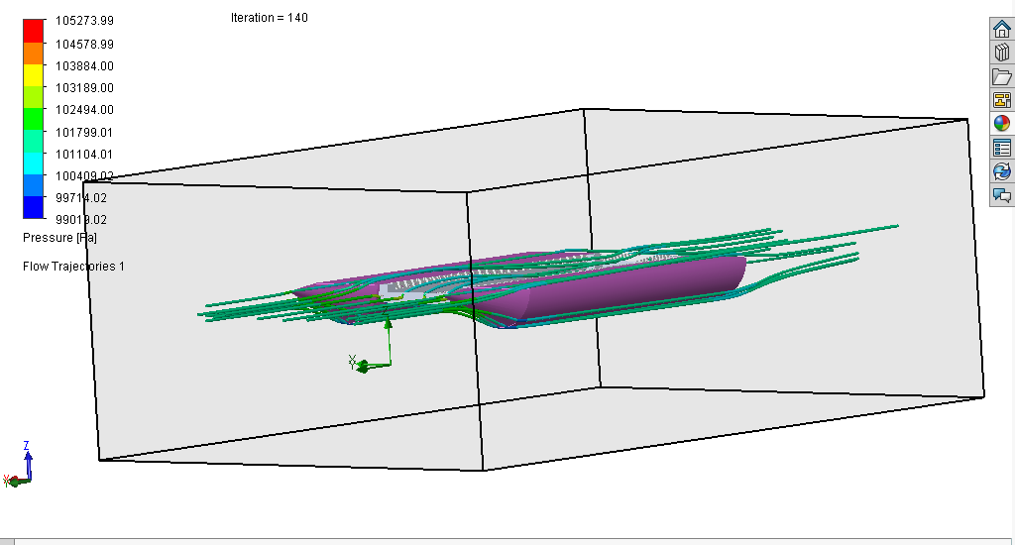

Figure 35 water flow around vessel

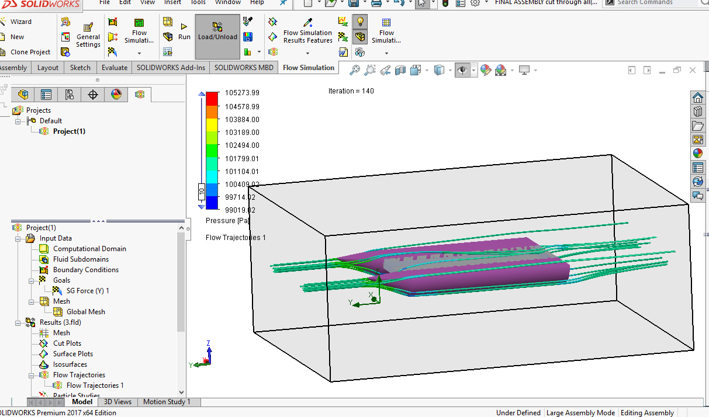

Figure 36 Flow trajectories

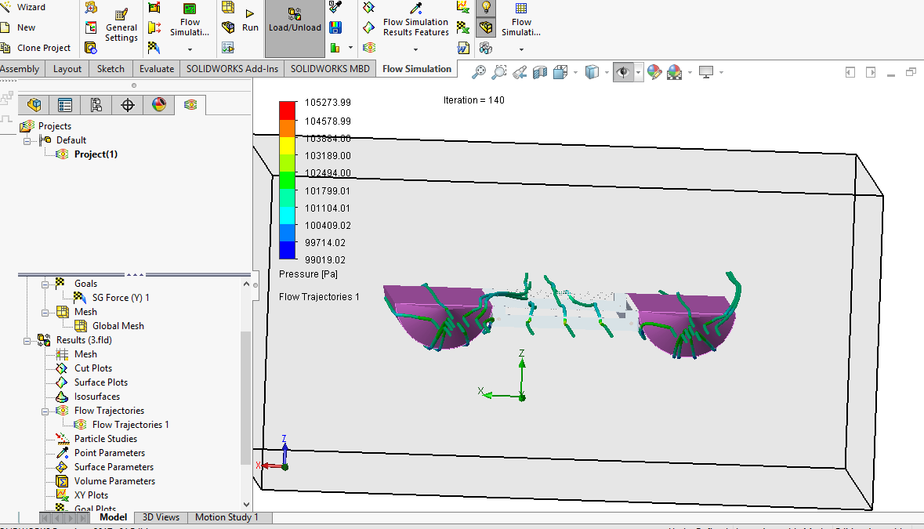

Figure 37 Flow trajectory 2

**Results:**

Through this flow simulation, I was able to see the flow of water through the vessel itself, not only that I was able to find Drag force which is about 29.37 N. This value will further help me run the stress analysis. Drag force will also be used to in order to identify the motor and power required to overcome this force.

**FEA analysis:**

Similar to Flow simulation, this was to be done using Solidworks, but after many crashed attempts, we decided to use inventor instead, Inventor meshes the product itself. The main problem with the vessel is the aluminum mesh that is around the collection chamber. Since the system is advanced, I will be running two simulations one without the collection chamber and one with the chamber. The wooden blocks that are supposed to hold the PVC together cannot be identified in inventor, so I ended up using silicon with same weight.

The forces that are applied in this case are following:

1: Drag Force

2: Weight of electronics and cargo

3: Buoyant force

The results showed only one failure point and that is because of the temperature change in silicon we used, the silicon melted and the PVC pipe pulled itself out of the coupling. In the actual vessel we are using oak wood blocks, also we are using epoxy to hold the system together. Epoxy and fixing option is not found in inventor, hence the issues.

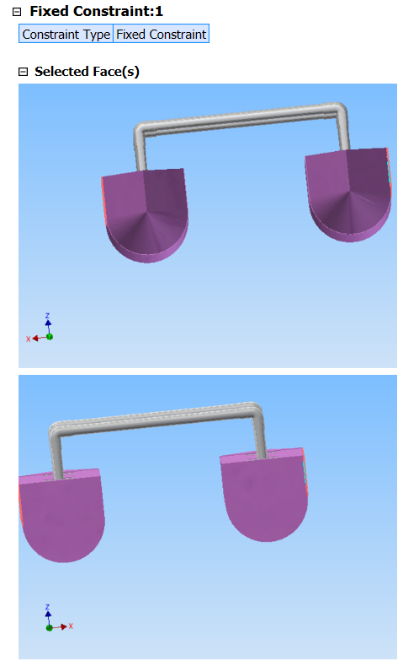

Figure 38 Fixed constraints

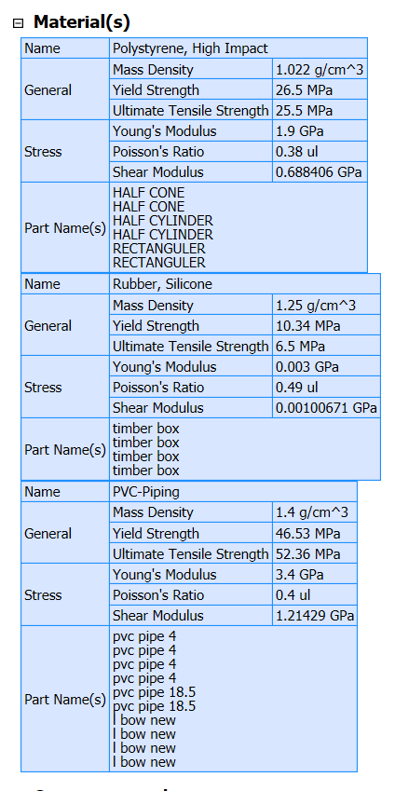

Figure 39 materials

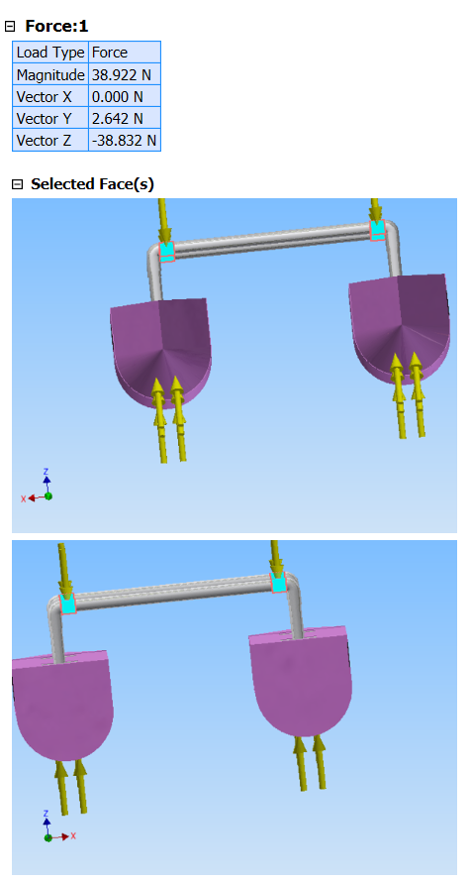

Figure 40 Forces

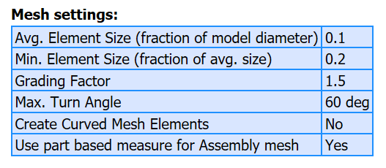

Figure 41 Mesh settings

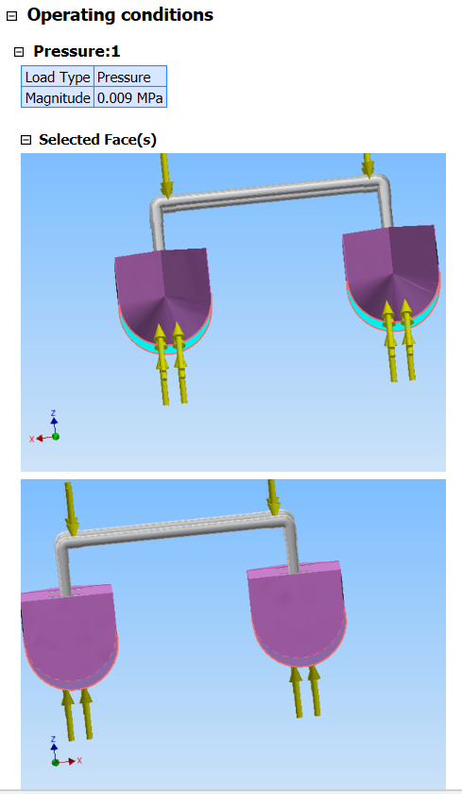

Figure 42 Pressure

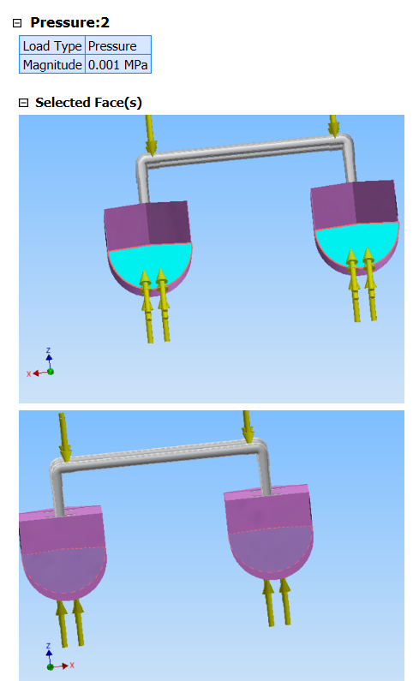

Figure 43 Pressure 2

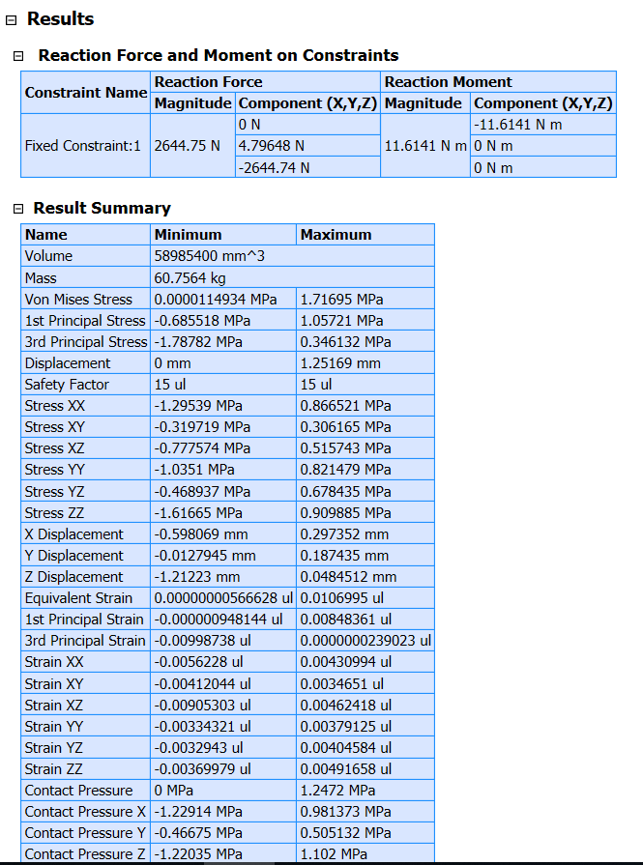

Figure 44 Result summary

Stress analysis (Whole System)

Last step is to run stress analysis on the whole system and apply all the materials and fixtures using

#### Physical

|  |  |
| --- | --- |
| Mass | 65.3553 kg |
| Area | 4.78583 m^2 |
| Volume | 0.0635279 m^3 |
| Center of Gravity | x=-0.0866133 m y=-0.353545 m z=0.21317 m |

Table 5 Physical properties

Note: Physical values could be different from Physical values used by FEA reported below.

## Static Analysis:1

**General objective and settings:**

|  |  |
| --- | --- |
| Design Objective | Single Point |
| Study Type | Static Analysis |
| Last Modification Date | 11/27/2018, 6:59 PM |
| Detect and Eliminate Rigid Body Modes | No |
| Separate Stresses Across Contact Surfaces | No |
| Motion Loads Analysis | No |

Table 6 General objective

Mesh settings:

|  |  |
| --- | --- |
| Avg. Element Size (fraction of model diameter) | 0.1 |
| Min. Element Size (fraction of avg. size) | 0.2 |
| Grading Factor | 1.5 |
| Max. Turn Angle | 60 deg |
| Create Curved Mesh Elements | No |
| Use part based measure for Assembly mesh | Yes |

Table 7 Mesh settings

 Material(s)

|  |  |  |
| --- | --- | --- |
| Name | Polystyrene, High Impact | |
| General | Mass Density | 1.022 g/cm^3 |
| Yield Strength | 26.5 MPa |
| Ultimate Tensile Strength | 25.5 MPa |
| Stress | Young's Modulus | 1.9 GPa |
| Poisson's Ratio | 0.38 ul |
| Shear Modulus | 0.688406 GPa |
| Part Name(s) | HALF CONE HALF CONE HALF CYLINDER HALF CYLINDER RECTANGULER RECTANGULER | |

|  |  |  |
| --- | --- | --- |
| Name | PPS Plastic | |
| General | Mass Density | 1.637 g/cm^3 |
| Yield Strength | 68.9 MPa |
| Ultimate Tensile Strength | 82.7 MPa |
| Stress | Young's Modulus | 2.7 GPa |
| Poisson's Ratio | 0.4 ul |
| Shear Modulus | 0.964286 GPa |
| Part Name(s) | timber box timber box timber box timber box electric box | |

|  |  |  |
| --- | --- | --- |
| Name | PVC-Piping | |
| General | Mass Density | 1.4 g/cm^3 |
| Yield Strength | 46.53 MPa |
| Ultimate Tensile Strength | 52.36 MPa |
| Stress | Young's Modulus | 3.4 GPa |
| Poisson's Ratio | 0.4 ul |
| Shear Modulus | 1.21429 GPa |
| Part Name(s) | pvc pipe 4 pvc pipe 4 pvc pipe 4 pvc pipe 4 pvc pipe 18.5 pvc pipe 18.5 l bow new l bow new l bow new l bow new | |

|  |  |  |
| --- | --- | --- |
| Name | Aluminum 6061 | |
| General | Mass Density | 2.7 g/cm^3 |
| Yield Strength | 275 MPa |
| Ultimate Tensile Strength | 310 MPa |
| Stress | Young's Modulus | 68.9 GPa |
| Poisson's Ratio | 0.33 ul |
| Shear Modulus | 25.9023 GPa |
| Part Name(s) | part middle case all aluminum | |

Table 8 Materials

Operating conditions

Pressure:1

|  |  |
| --- | --- |
| Load Type | Pressure |
| Magnitude | 0.009 MPa |

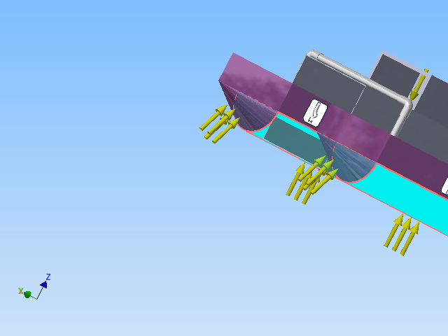

Figure 45 Selected faces

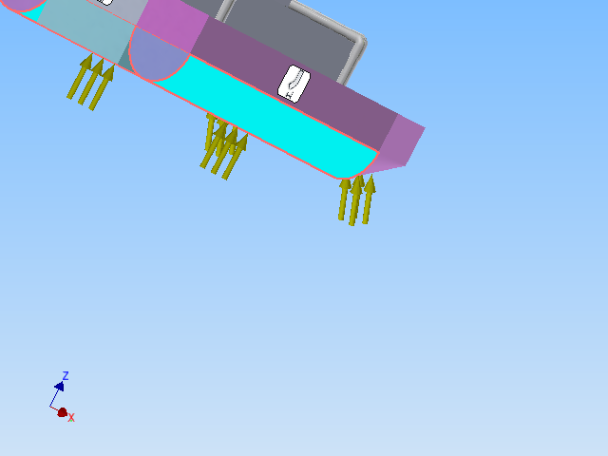

Figure 46 Pressure 1

 Pressure:2

|  |  |
| --- | --- |
| Load Type | Pressure |
| Magnitude | 0.001 MPa |

##### Selected Face(s)

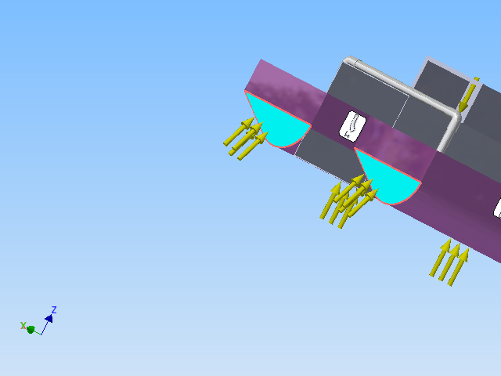

Figure 47 Pressure 2

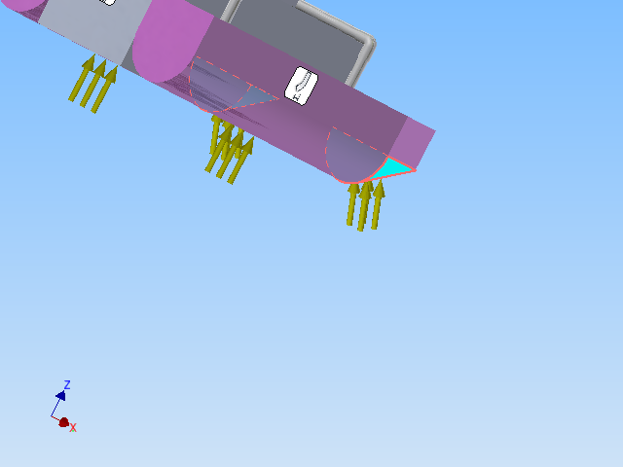

Figure 48 Pressuer 2

 Force:1

|  |  |
| --- | --- |
| Load Type | Force |
| Magnitude | 44.480 N |
| Vector X | 0.000 N |
| Vector Y | 0.000 N |
| Vector Z | -44.480 N |

Table 9 Force 1

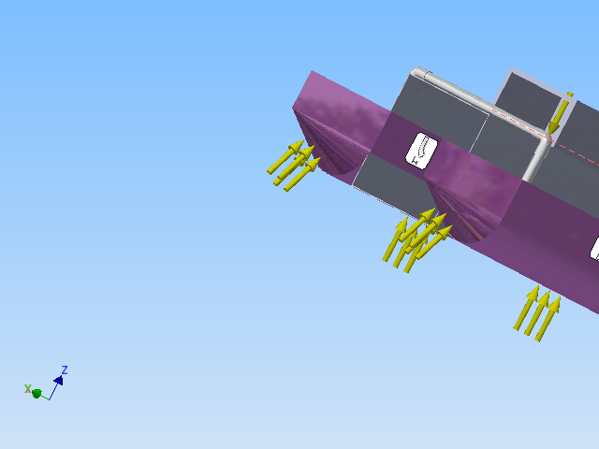

Figure 49 Force 1

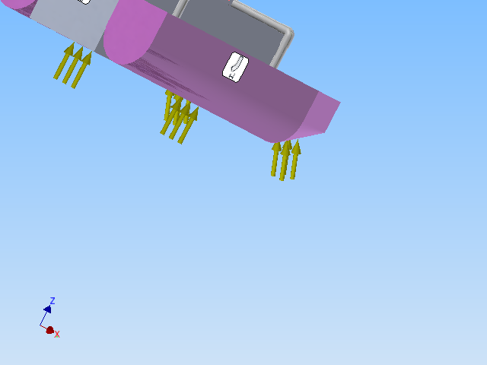

Figure 50 Force 1

#### Force:2

|  |  |
| --- | --- |
| Load Type | Force |
| Magnitude | 111.207 N |
| Vector X | 0.000 N |
| Vector Y | -0.000 N |
| Vector Z | -111.207 N |

Table 10 Force 2

 Selected Face(s)

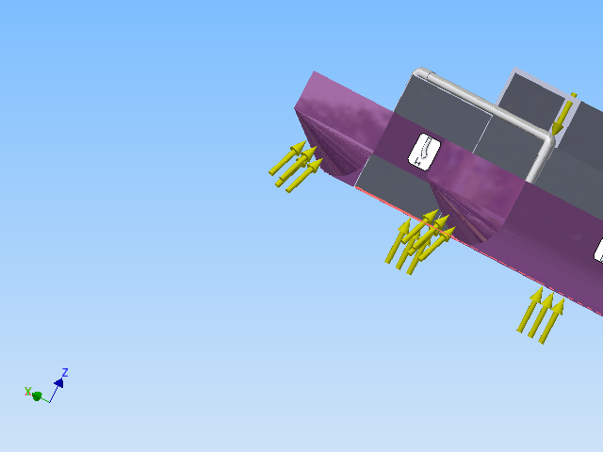

Figure 51 Selected faces

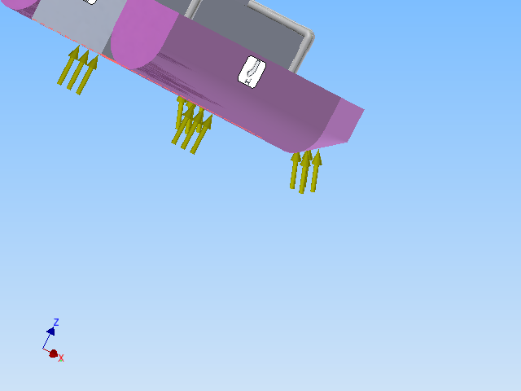

Figure 52 Force 2

#### Fixed Constraint:1

|  |  |
| --- | --- |
| Constraint Type | Fixed Constraint |

Selected Face(s)

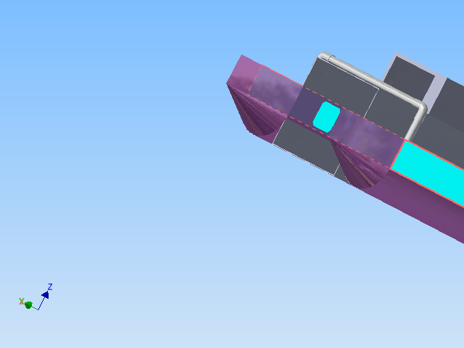

Figure 53 Selected faces

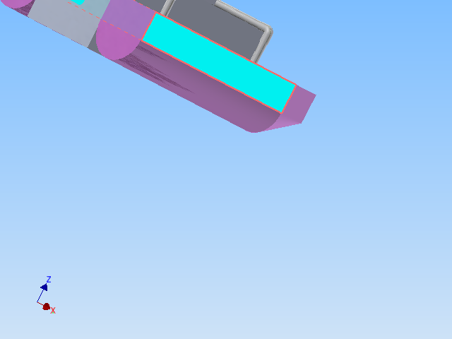

Figure 54 Selected faces fixture

Contacts (Bonded)

|  |  |
| --- | --- |
| Name | Part Name(s) |
| Bonded:1 | RECTANGULER:2 timber box:4 |
| Bonded:2 | RECTANGULER:1 timber box:1 |
| Bonded:3 | RECTANGULER:1 timber box:1 |
| Bonded:4 | RECTANGULER:2 timber box:4 |
| Bonded:5 | RECTANGULER:1 timber box:1 |
| Bonded:6 | RECTANGULER:2 timber box:4 |
| Bonded:7 | RECTANGULER:2 timber box:4 |
| Bonded:8 | RECTANGULER:1 timber box:1 |
| Bonded:9 | RECTANGULER:1 timber box:1 |
| Bonded:10 | RECTANGULER:2 timber box:4 |
| Bonded:11 | RECTANGULER:1 timber box:2 |
| Bonded:12 | RECTANGULER:2 timber box:3 |
| Bonded:13 | RECTANGULER:2 timber box:3 |
| Bonded:14 | RECTANGULER:1 timber box:2 |
| Bonded:15 | RECTANGULER:1 timber box:2 |
| Bonded:16 | RECTANGULER:2 timber box:3 |
| Bonded:17 | timber box:1 pvc pipe 4:3 |
| Bonded:18 | RECTANGULER:1 timber box:2 |
| Bonded:19 | RECTANGULER:2 timber box:3 |
| Bonded:20 | timber box:2 pvc pipe 4:2 |
| Bonded:21 | timber box:3 pvc pipe 4:4 |
| Bonded:22 | timber box:4 pvc pipe 4:1 |
| Bonded:23 | timber box:1 pvc pipe 4:3 |
| Bonded:24 | RECTANGULER:1 timber box:2 |
| Bonded:25 | RECTANGULER:2 timber box:3 |
| Bonded:26 | timber box:2 pvc pipe 4:2 |
| Bonded:27 | timber box:3 pvc pipe 4:4 |
| Bonded:28 | timber box:4 pvc pipe 4:1 |
| Bonded:29 | pvc pipe 4:2 l bow new:2 |
| Bonded:30 | pvc pipe 4:3 l bow new:4 |
| Bonded:31 | pvc pipe 4:4 l bow new:1 |
| Bonded:32 | pvc pipe 18.5:2 l bow new:3 |
| Bonded:33 | RECTANGULER:1 part middle case all aluminum:1 |
| Bonded:34 | part middle case all aluminum:1 electric box:1 |
| Bonded:35 | pvc pipe 4:1 l bow new:3 |
| Bonded:36 | pvc pipe 18.5:1 l bow new:1 |
| Bonded:37 | HALF CONE:2 RECTANGULER:1 |
| Bonded:38 | HALF CONE:1 RECTANGULER:2 |
| Bonded:39 | HALF CONE:1 HALF CYLINDER:1 |
| Bonded:40 | HALF CONE:2 HALF CYLINDER:2 |
| Bonded:41 | HALF CYLINDER:2 RECTANGULER:1 |
| Bonded:42 | HALF CYLINDER:1 RECTANGULER:2 |
| Bonded:43 | HALF CYLINDER:2 part middle case all aluminum:1 |
| Bonded:44 | HALF CYLINDER:1 part middle case all aluminum:1 |
| Bonded:45 | RECTANGULER:2 part middle case all aluminum:1 |

Table 11 Bonds

Results

Reaction Force and Moment on Constraints

|  |  |  |  |  |
| --- | --- | --- | --- | --- |
| **Constraint Name** | **Reaction Force** | | **Reaction Moment** | |
| **Magnitude** | **Component (X,Y,Z)** | **Magnitude** | **Component (X,Y,Z)** |
| Fixed Constraint:1 | 2527.93 N | 0 N | 11.6762 N m | -11.6762 N m |
| 14.9663 N | 0 N m |
| -2527.89 N | 0 N m |

Table 12 Reaction Forces

Result Summary

|  |  |  |
| --- | --- | --- |
| **Name** | **Minimum** | **Maximum** |
| Volume | 63527900 mm^3 | |
| Mass | 71.4218 kg | |
| Von Mises Stress | 0.00000066323 MPa | 3.333 MPa |
| 1st Principal Stress | -0.840666 MPa | 2.82522 MPa |
| 3rd Principal Stress | -3.2432 MPa | 1.257 MPa |
| Displacement | 0 mm | 0.160998 mm |
| Safety Factor | 15 ul | 15 ul |
| Stress XX | -2.7084 MPa | 2.63936 MPa |
| Stress XY | -0.54475 MPa | 0.548962 MPa |
| Stress XZ | -1.4552 MPa | 1.3929 MPa |
| Stress YY | -1.09942 MPa | 1.25918 MPa |
| Stress YZ | -0.339979 MPa | 0.773526 MPa |
| Stress ZZ | -3.23762 MPa | 2.82242 MPa |
| X Displacement | -0.00946153 mm | 0.00953897 mm |
| Y Displacement | -0.00114884 mm | 0.0154656 mm |
| Z Displacement | -0.160998 mm | 0.018783 mm |
| Equivalent Strain | 0.00000000019701 ul | 0.0000436901 ul |
| 1st Principal Strain | -0.000000202602 ul | 0.0000369209 ul |
| 3rd Principal Strain | -0.0000454897 ul | 0.000000775057 ul |
| Strain XX | -0.0000354651 ul | 0.0000341433 ul |
| Strain XY | -0.0000172027 ul | 0.0000127968 ul |
| Strain XZ | -0.0000280902 ul | 0.0000268876 ul |
| Strain YY | -0.0000138316 ul | 0.0000134103 ul |
| Strain YZ | -0.00000656272 ul | 0.00001764 ul |
| Strain ZZ | -0.0000453819 ul | 0.0000367485 ul |
| Contact Pressure | 0 MPa | 1.05001 MPa |
| Contact Pressure X | -1.01768 MPa | 0.786651 MPa |
| Contact Pressure Y | -0.254685 MPa | 0.298772 MPa |
| Contact Pressure Z | -0.151817 MPa | 0.289182 MPa |

Table 13 Results

Figures

Von Mises Stress

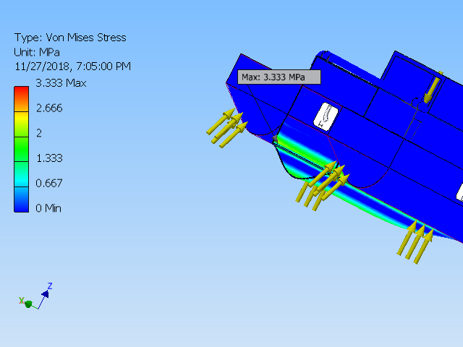

Figure 55 Von Mises Stress

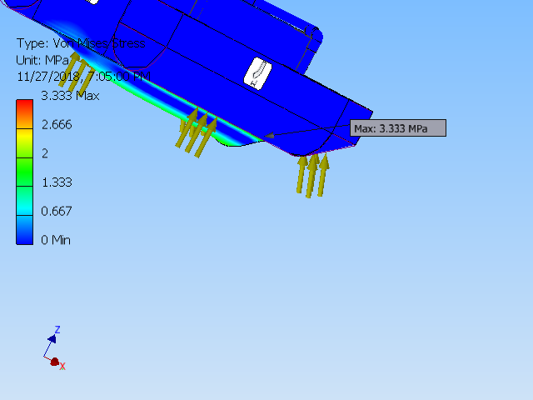

Figure 56 Min to Max Von mises stress

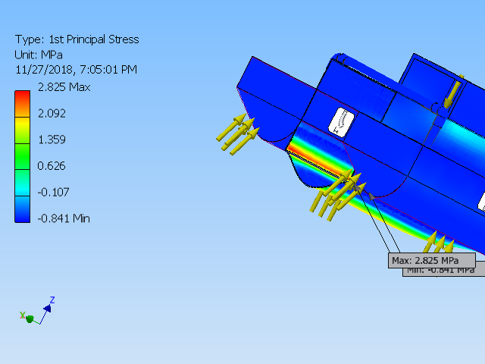

Figure 57 1st principle stress

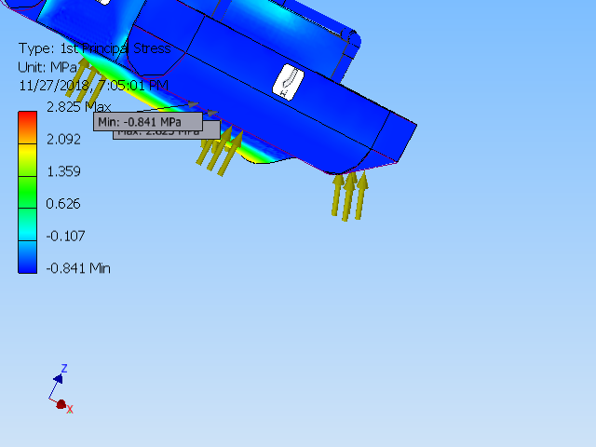

Figure 58 Max and Min principle stress

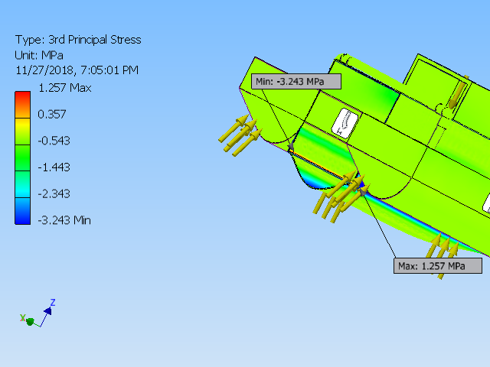

Figure 59 3rd principle stress

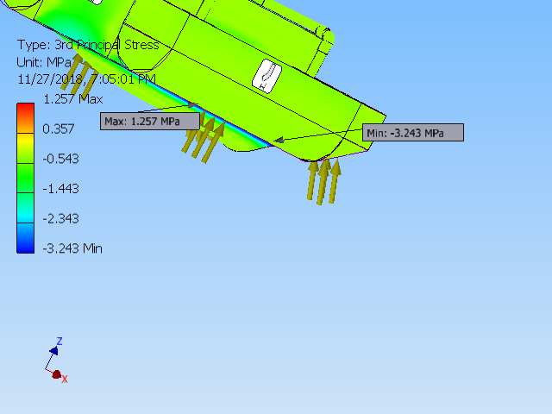

Figure 60 Displacement

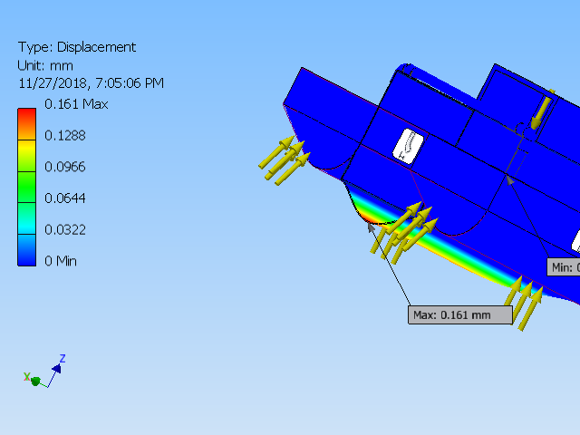

Figure 61 Max and Min Displacement

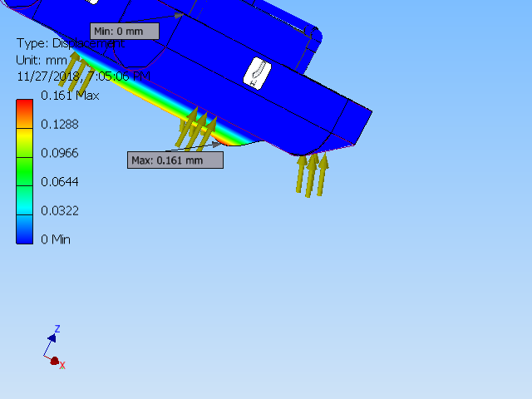

Figure 62 Displacement Max point

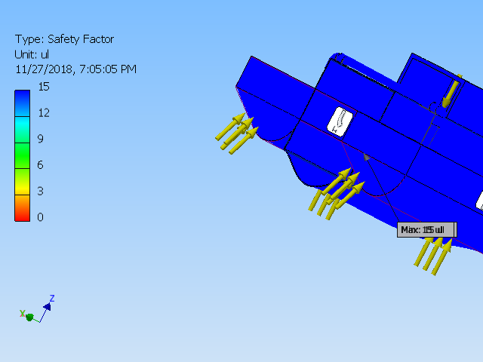

Figure 63 Safety Factor

Power Calculation:

The power calculation is required in order to determine the motor and propeller for this vessel to achieve the velocity at the acceleration according to design requirements. For this, the process is following:

1: First Calculate acceleration

2: Calculate thrust force required.

3: Calculate Power based on thrust force.

4: Choose a propeller and calculate the RPM required based on speed and the radius of the prop.

4: Use the RPM and Power to find a motor.

Results:

Based on the thrust force required, I determined that, we need 80W power to overcome drag force.

I then passed this information to my partner who then determined the motor and did power analysis.

## Implementation of task 8

Setting up the image recognition API

HARDWARE

Before we can have an image recognition system we must first determine which platform to use. Image recognition can be implemented on various Operating systems and devices but due to the mobility of the boat and flexibility, we settled for the raspberry pi 3. However, we will be training our model on a windows desktop but the recognition will be implemented on the field with a raspberry pi3. Below are the list of deceives required.

* Raspberry pi 3
* Webcam / pi cam
* Micro SD card {containing the Rasbian OS}
* A personal computer
* Portable Power Supply
* Wireless Wi-Fi dongle
* Mouse
* Keyboard

SOFTWARE

Certain steps and configuration has to be taken before the raspberry pi can be operational and this steps will be highlighted below.

* Update the raspberry pi
* Install Tensorflow
* Install openCV
* Compile and install Protobuf
* Set up Tensor flow directory Structure and the PYTHONPATH variable
* Test the system
* This steps will be explain comprehensives below

Update the Raspberry Pi

sudo apt-get update

sudo apt-get dist-upgrade

The first line command updates the pi while the second on upgrades it. Note that dist-upgrade should be used instead of just upgrade in other to avoid errors in future coding operations. The time taken will vary based on the version of pi being used.

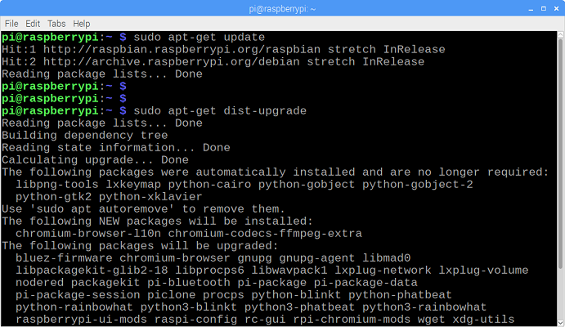

Figure 64 pi graphic interface during update

1. Install Tensor flow

Tensor flow is our optimizer and it is very important in the recognition process. To install, In the /home/pi directory, create a folder called ‘tf’, which will be used to hold all the installation files for TensorFlow.

mkdir tf

cd tf

wget <https://github.com/lhelontra/tensorflow-on-arm/releases/download/v1.8.0/tensorflow-1.8.0-cp35-none-linux_armv7l.whl>

install TensorFlow by issuing:

sudo pip3 install /home/pi/tf/tensorflow-1.8.0-cp35-none-linux_armv7l.whl

TensorFlow also needs the LibAtlas, pillow, lxml, jupyter, matplotlib, cython packages

sudo apt-get install libatlas-base-dev

sudo pip3 install pillow lxml jupyter matplotlib cython

sudo apt-get install python-tk

1. Install OpenCV

To get OpenCV working on the Raspberry Pi, there’s quite a few dependencies that need to be installed through apt-get. If any of the following commands don’t work, issue “sudo apt-get update” and then try again. Issue:

sudo apt-get install libjpeg-dev libtiff5-dev libjasper-dev libpng12-dev

sudo apt-get install libavcodec-dev libavformat-dev libswscale-dev libv4l-dev

sudo apt-get install libxvidcore-dev libx264-dev

sudo apt-get install qt4-dev-tools

Now that we’ve got all those installed, install OpenCV. Issue:

pip3 install opencv-python

1. Compile and install Protobuf

The TensorFlow object detection API uses Protobuf, a package that implements Google’s Protocol Buffer data format. First, get the packages needed to compile Protobuf from source. Issue:

sudo apt-get install autoconf automake libtool curl

Then download the protobuf release from its GitHub repository by issuing:

wget https://github.com/google/protobuf/releases/download/v3.5.1/protobuf-all-3.5.1.tar.gz

Configure the build by issuing the following command

./configure

Build the package by issuing:

make

make check

make install

Export the library path:

cd python

export LD_LIBRARY_PATH=../src/.libs

Next, issue:

python3 setup.py build --cpp_implementation

python3 setup.py test --cpp_implementation

sudo python3 setup.py install --cpp_implementation

Then issue the following path commands:

export PROTOCOL_BUFFERS_PYTHON_IMPLEMENTATION=cpp

export PROTOCOL_BUFFERS_PYTHON_IMPLEMENTATION_VERSION=3

Finally, issue:

sudo ldconfig

That’s it! Now Protobuf is installed on the Pi. Verify it’s installed correctly by issuing the command below and making sure it puts out the default help text.

protoc

The Raspberry Pi needs to be restarted after this process, or TensorFlow will not work.

sudo reboot now

1. Set up TensorFlow Directory Structure and PYTHONPATH Variable

mkdir tensorflow1

cd tensorflow1

Download the tensorflow repository from GitHub by issuing:

git clone --recurse-submodules https://github.com/tensorflow/models.git

Next, modify the PYTHONPATH environment variable to point at some directories inside the TensorFlow repository downloaded

sudo nano ~/.baser

Move to the end of the file, and on the last line, add:

export PYTHONPATH=$PYTHONPATH:/home/pi/tensorflow1/models/research:/home/pi/tensorflow1/models/research/slim

Use Protoc to compile the Protocol Buffer (.proto) files used by the Object Detection API. The .proto files are located in /research/object_detection/protos

cd /home/pi/tensorflow1/models/research

protoc object_detection/protos/*.proto --python_out=.

This command converts all the "name".proto files to "name_pb2".py

cd /home/pi/tensorflow1/models/research/object_detection

The raspberry pi is ready to accept a trained cnn model in order to start recognition

Research on Convolution Neural Network

During the course of designing this bottle collection system, we deliberated on several ways of making this machine intelligent in different ways such as using a thermal camera, or a sonar sensor in identifying objects but unfortunately, all the methods where not efficient enough except for the use of image recognition. By implementing image recognition with the aid of artificial intelligence, we would be able to identify specific objects which will be collected and avoid unwanted obstacles. Although complicated to a degree, it is practical.

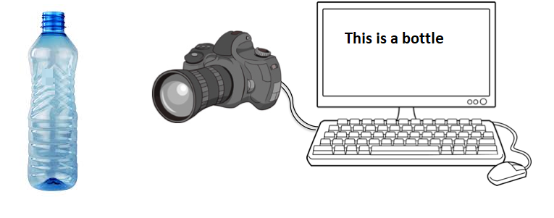

Figure 65 overview

Image recognition is a great task for developing and testing machine learning approaches. Vision is debatably our most powerful sense and comes naturally to us humans.

Image recognition can be practicalized in 2 different ways such as supervised learning and Unsupervised. On this project we will be making use of supervised learning since our objective is well defined. In Supervised learning, we supply the computer a dataset of images and specify a general process of how the computer should be able to evaluate images then the system will be able learn by working with defined mathematical model which links the input image to the output model. With the use of Artificial intelligence during the training stage, the system learns and corrects its parameters till a high degree of accuracy is established. The whole thing turns out to be an optimizing problem.

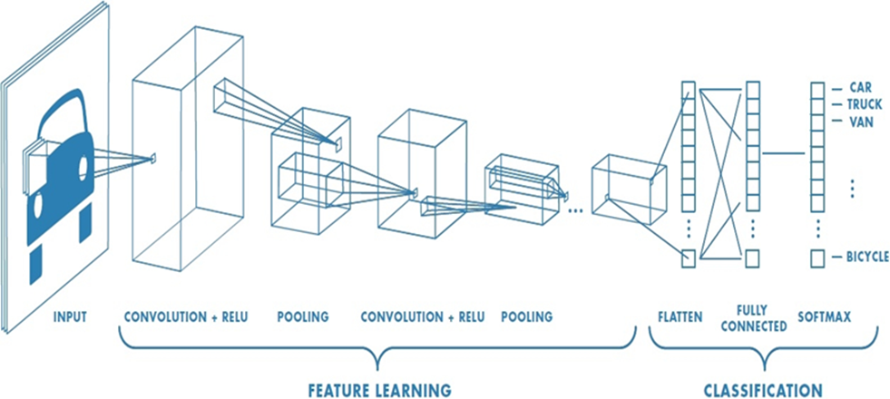

Figure 66 pictorial representation of CNN

In every cnn, there are 2 stages, the feature stage and the classification stage. At the classification stage, the input (picture or video feeds broken down in frames) is converted to pixel values, these values are passed through filters and these filters have specific values in matrix form which are convoluted with the pixel values and the output is convoluted again with more filters. The more filters, parameters and layers the more precise the cnn tends to be however, the speed will be affected negatively so, when chosen a cnn depending on the use, speed and accuracy must be taken into consideration. Operations such as Pooling and striding are employed to manipulate the size of the convolution matrix. The arrays of the parameters are aligned to form a single in the classification section then compared to the softmax.

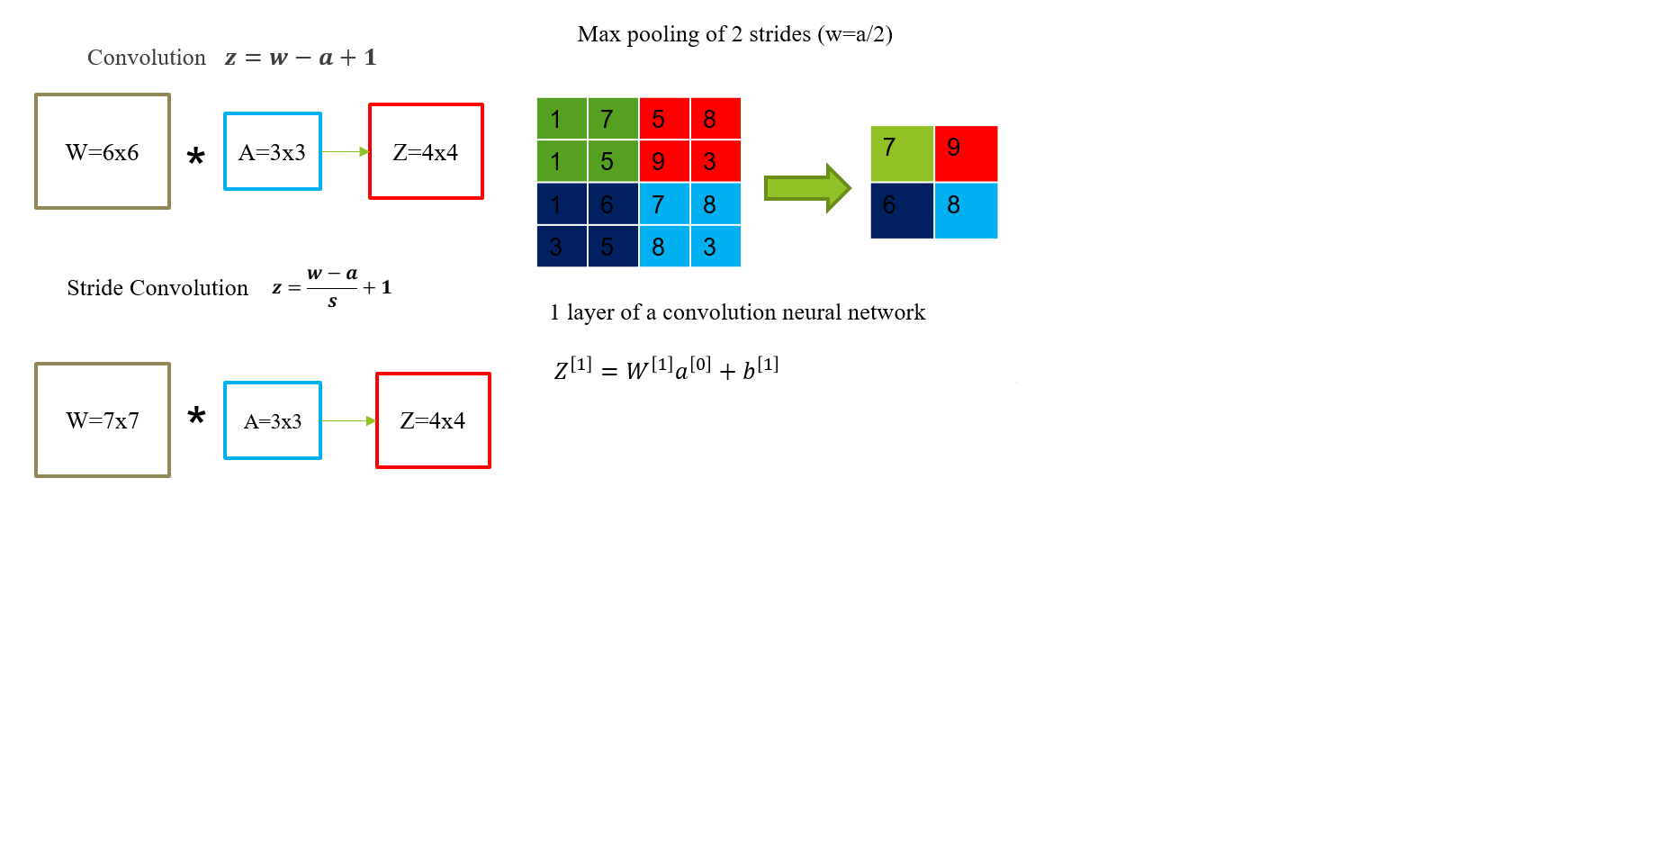

Figure 67 neural network modification methods

In order to develop or comprehend a cnn, some manipulations processes must be understood. These manipulations are used to move from one layer to another while refining the parameters in the feature learning stage. The diagram above exhibits 3 of this manipulations.

Convolution is the method of combining the pixel values and the filter. For every single convolution process, a patch is generated in the next layer*. $z=w-a+1$*  is the equation used to determine the matrix size of the output parameters.

Strided convolution is similar to plain convolution, it deserves depending on the number of stride, the more the stride, the lesser the number of parameters in the matrices. Output matrix size can be derived by

$$z=\frac{w-a}{s}+1$$

Max pooling doesn’t involve the use of a filter, it is a process of shrinking a matrix. Max pooling is implemented above in a stride of 2, the max value is selected and that forms a patch in the output matrix.

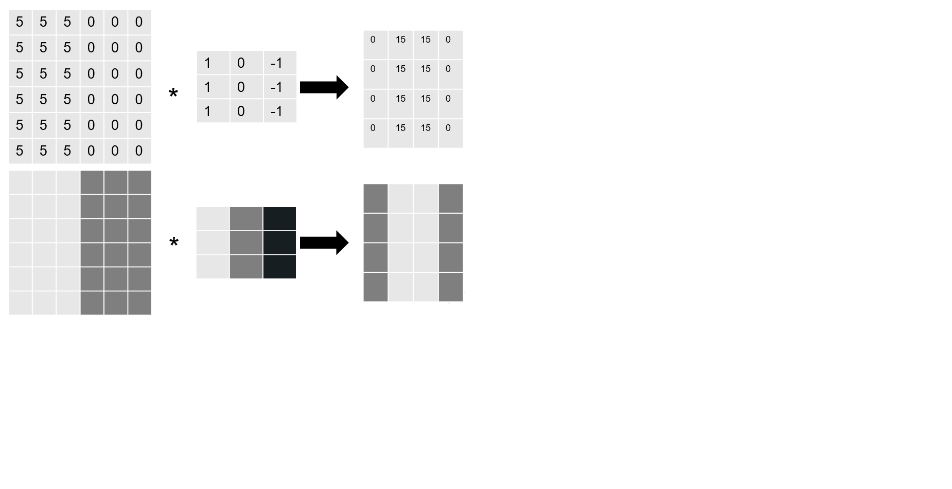

Figure 68 edge detection

The above diagram is a pictorial representation of how a vertical edge detection filter works. When a random pixel values is convoluted with the filter above, it gives specific pattern. If a clearly defined pattern as shown above is acquired where the light and dark regions are aligned, a vertical edge will be detected.

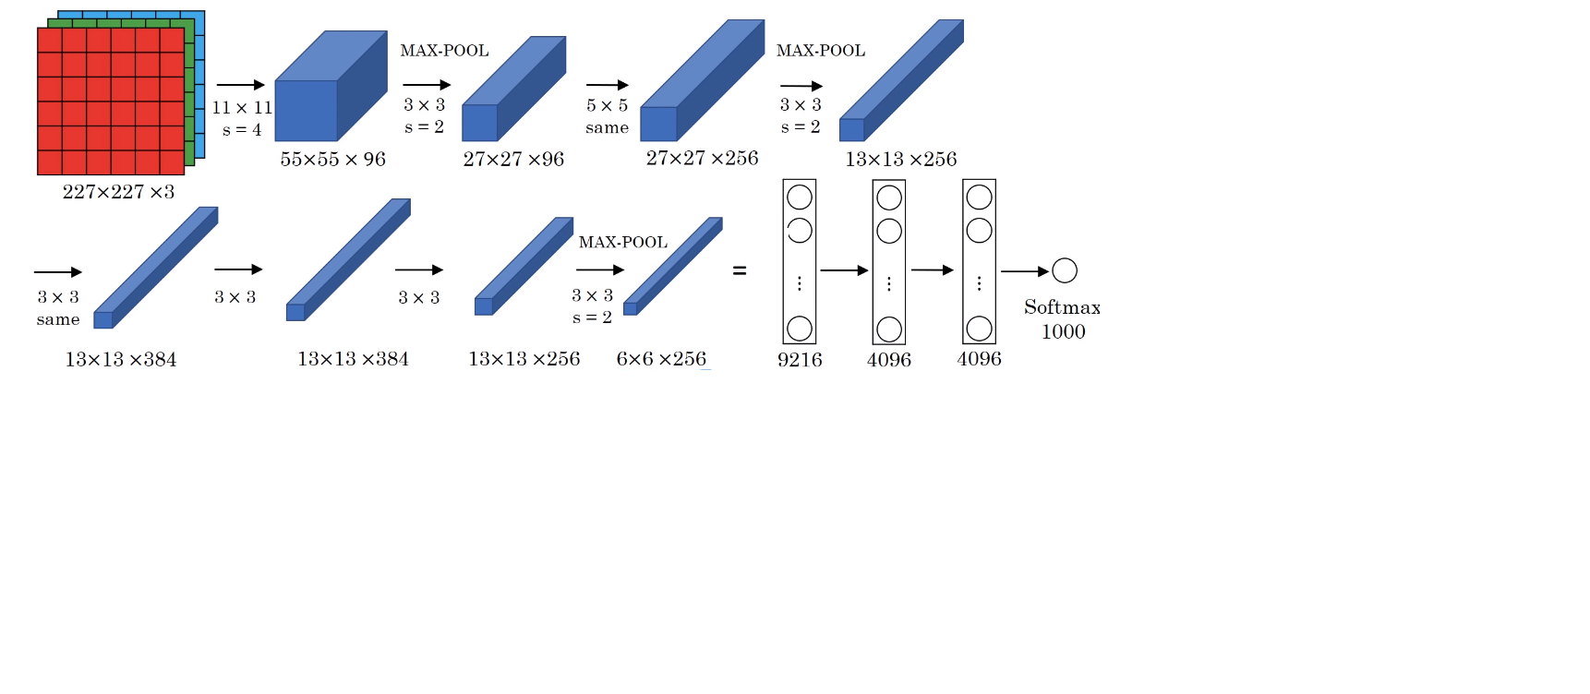

Figure 69 example for an inception neural network image processing

Above is the inception neural network which will be used for implementing the training. The cnn above has 8 layers, 1984 nodes and above 6 million. The networks has already been pre-trained by google and by applying transfer learning, I’ll be able to adapt the cnn to my training by introducing my dataset to the network. Above is 227x227x3 RGB image convoluted with a 11x11x3 filter with a stride of 3 to get a second layer 55x55x96, max pooling was also used between layers.

* The convolution layers have different parameter vales weight(w) and biases(b) from the equation $Z^{\left[1\right]}=W^{\left[1\right]}a^{\left[0\right]}+b^{\left[1\right]}$
* Cost function $j=\frac{1}{m}\sum_{i=1}^{m}{L({\hat{y}}^{\left(i\right)},y^{(i)}) }$
* w, b are randomly initialized. J is the sum of losses
* To train the neuro-network, the gradient decent is used. Tensor flow is employed to optimize all the parameters in the neuro-network with the aim of reducing the cost function J

TensorFlow is an open source software library for machine learning, which was released by Google in 2015 and has quickly become one of the most popular machine learning libraries being used by researchers and practitioners all over the world. It’s used to do the numerical heavy lifting for our image classification model. During training the model's predictions are compared to their true values. This information is then used to update the parameters. During testing there is no feedback anymore, the model simply generates labels.

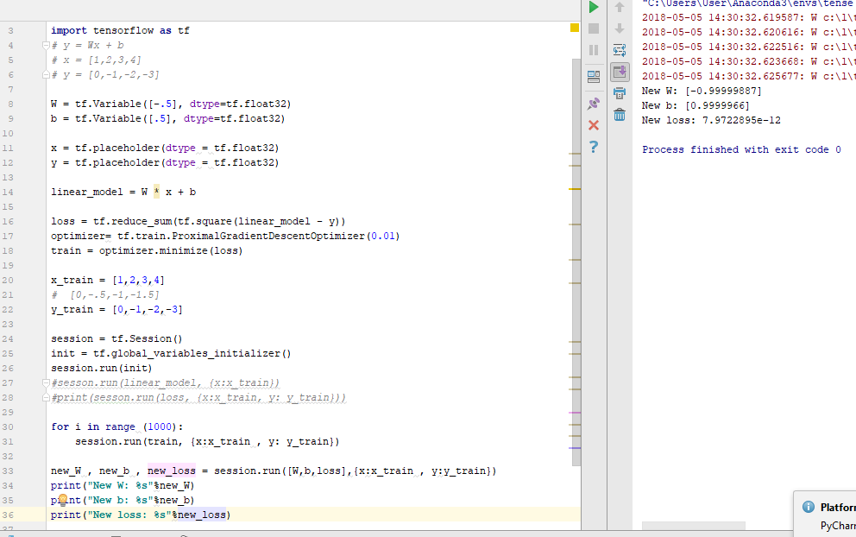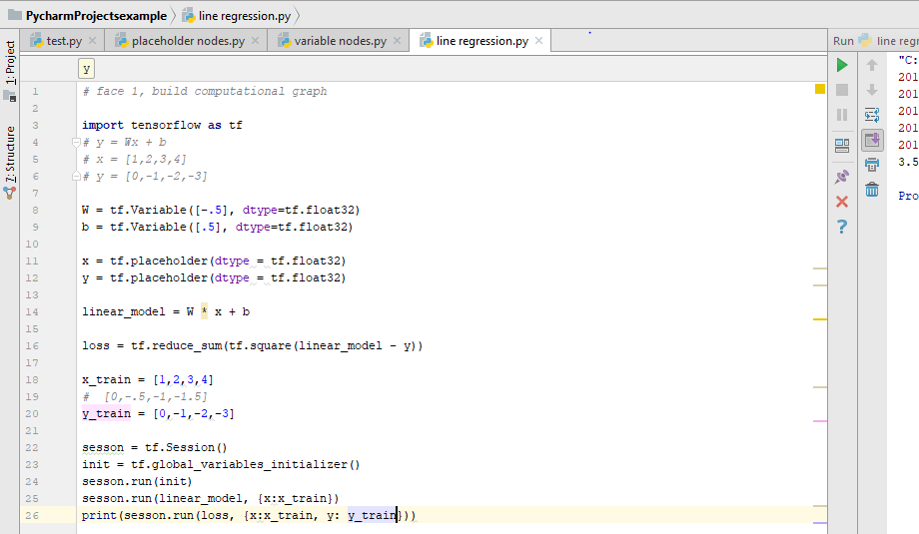

Figure 70 finding the error Figure 71 optimized process

𝑦_2=𝑤𝑥+𝑏

Error = $\sum_{0}^{3}{{(y_{2}-y_{1})}^{2}}$

The error in the value obtained which is 3.5 using out assumed values for w and b. The point is to train the code to minimize the error as much as possible.

Training of a line regression, error is reduced to 7.9722𝑒^(−12). New value for w = -1, New value for b = 1.

Training the model

Below are the steps required to successfully train a working model:

* Installing Tensorflow-GPU
* Setting up anaconda Virtual Environment and the Object Detection directory structure
* Gathering and labeling pictures
* Generating training data
* Creating a label map and configuring training
* Training
* Exporting the inference graph
* Upload into the raspberry pi3 and test.

1. Installing Tensorflow-GPU :

In order to make install tensorflow, installing some dependencies required by the GPU is required. A desktop with GPU GeForce GTX 1050 is being used. Tensorflow requires CUDA 9.0 and cuDNN 7.1.

Unfortunately, they aren’t compatible with a newer version of tensorflow so a downgrade to version 1.5 is necessary.

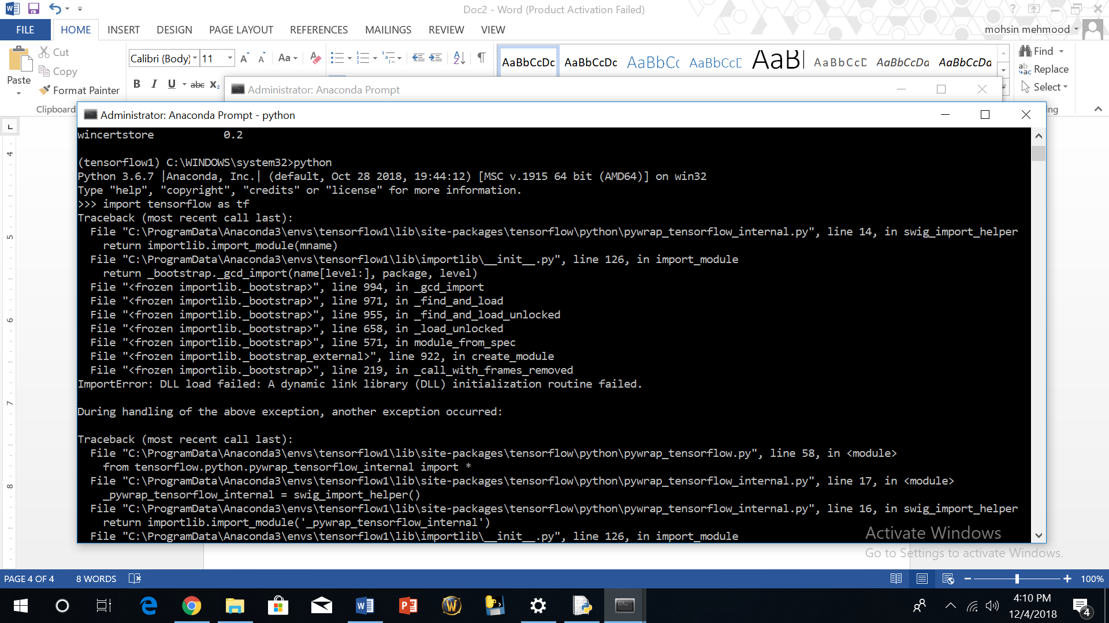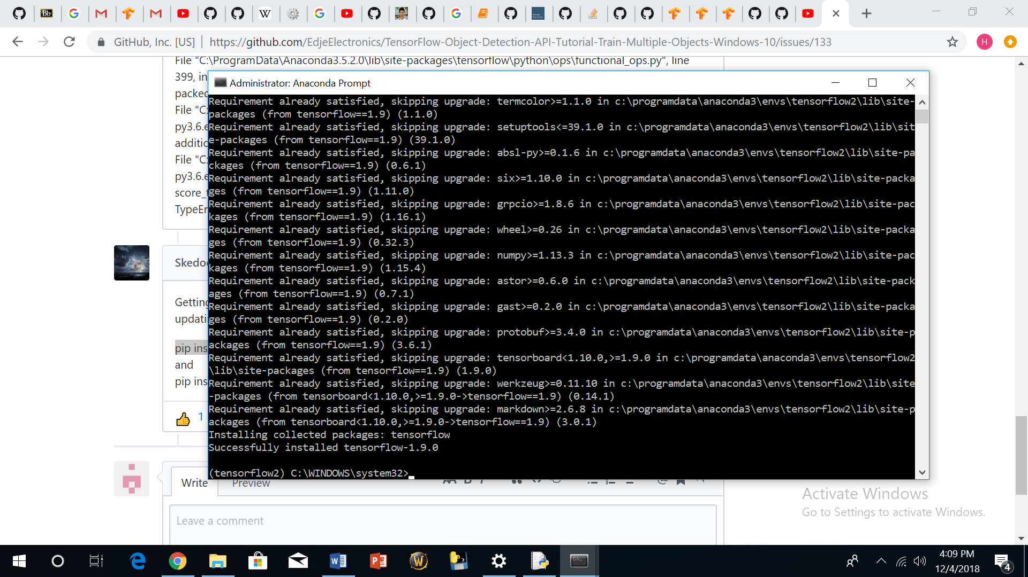

Figure 72 installing tf 12.0 Figure 73 failed installation

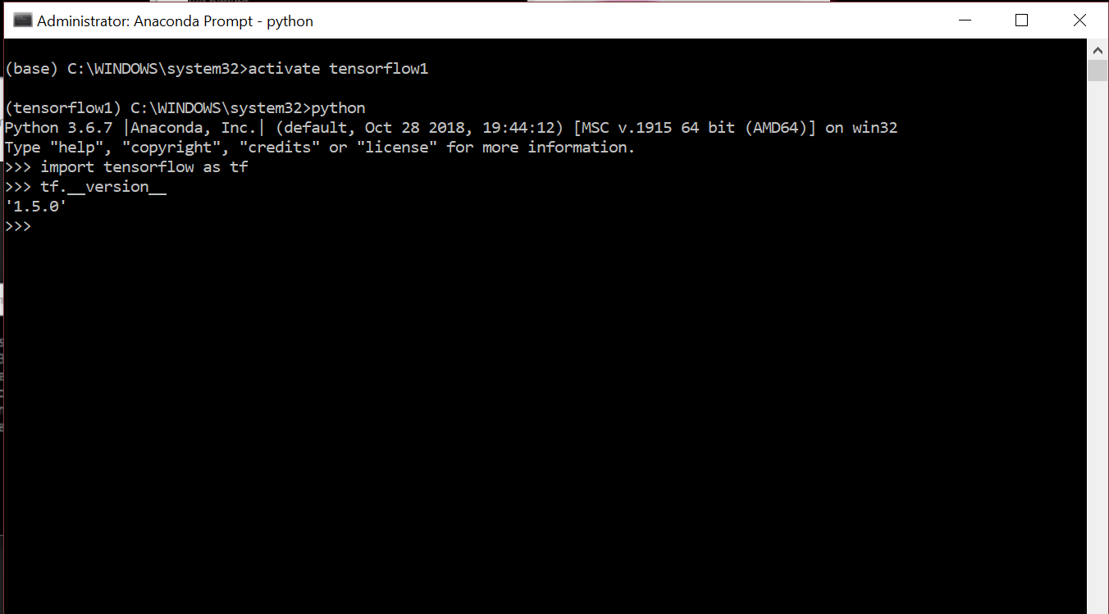

Figure 74 successful installation

1. Setting up anaconda Virtual Environment and the Object Detection directory structure

Training will the done with the ssd-Mobilenet model, it has the same structure as the inception neural network but with lesser parameters. Due to the weak processing power of the raspberry pi3, we require a neural network that would be fast enough unfortunately, accuracy will be a trade-off.

Then an environment on anaconda must be created

C:\> conda create -n tensorflow1 pip python=3.5

Then activate the environment by

C :\> activate tensorflow1

Other dependencies are required and they will be installed by issuing

(tensorflow1) C:\> conda install -c anaconda protobuf

(tensorflow1) C:\> pip install pillow

(tensorflow1) C:\> pip install lxml

(tensorflow1) C:\> pip install Cython

(tensorflow1) C:\> pip install jupyter

(tensorflow1) C :\> pip install matplotlib

(tensorflow1) C:\> pip install pandas

(tensorflow1) C:\> pip install opencv-python

We need to configure the PYTHONPATH environmental variable by issuing

(tensorflow1)C:\>setPYTHONPATH=C:\tensorflow1\models;C:\tensorflow1\models\research;C:\tensorflow1\models\research\slim

Next, compile protobuf

protoc--python_out=..\object_detection\protos\anchor_generator.proto .\object_detection\protos\argmax_matcher.proto.\object_detection\protos\bipartite_matcher.proto.\object_detection\protos\box_coder.proto.\object_detection\protos\box_predictor.proto.\object_detection\protos\eval.proto.\object_detection\protos\faster_rcnn.proto .\object_detection\protos\faster_rcnn_box_coder.proto.\object_detection\protos\grid_anchor_generator.proto.\object_detection\protos\hyperparams.proto.\object_detection\protos\image_resizer.proto.\object_detection\protos\input_reader.proto.\object_detection\protos\losses.proto.\object_detection\protos\matcher.proto.\object_detection\protos\mean_stddev_box_coder.proto.\object_detection\protos\model.proto.\object_detection\protos\optimizer.proto .\object_detection\protos\pipeline.proto.\object_detection\protos\post_processing.proto .\object_detection\protos\preprocessor.proto.\object_detection\protos\region_similarity_calculator.proto.\object_detection\protos\square_box_coder.proto.\object_detection\protos\ssd.proto.\object_detection\protos\ssd_anchor_generator.proto.\object_detection\protos\string_int_label_map.proto.\object_detection\protos\train.proto.\object_detection\protos\keypoint_box_coder.proto.\object_detection\protos\multiscale_anchor_generator.proto.\object_detection\protos\graph_rewriter.proto

To test if the tensorflow set up is functional, run a jupyter script. If there is no error and the pictures below are identified, everything is fine.

(tensorflow1) C:\tensorflow1\models\research\object_detection> jupyter notebook object_detection_tutorial.ipynb

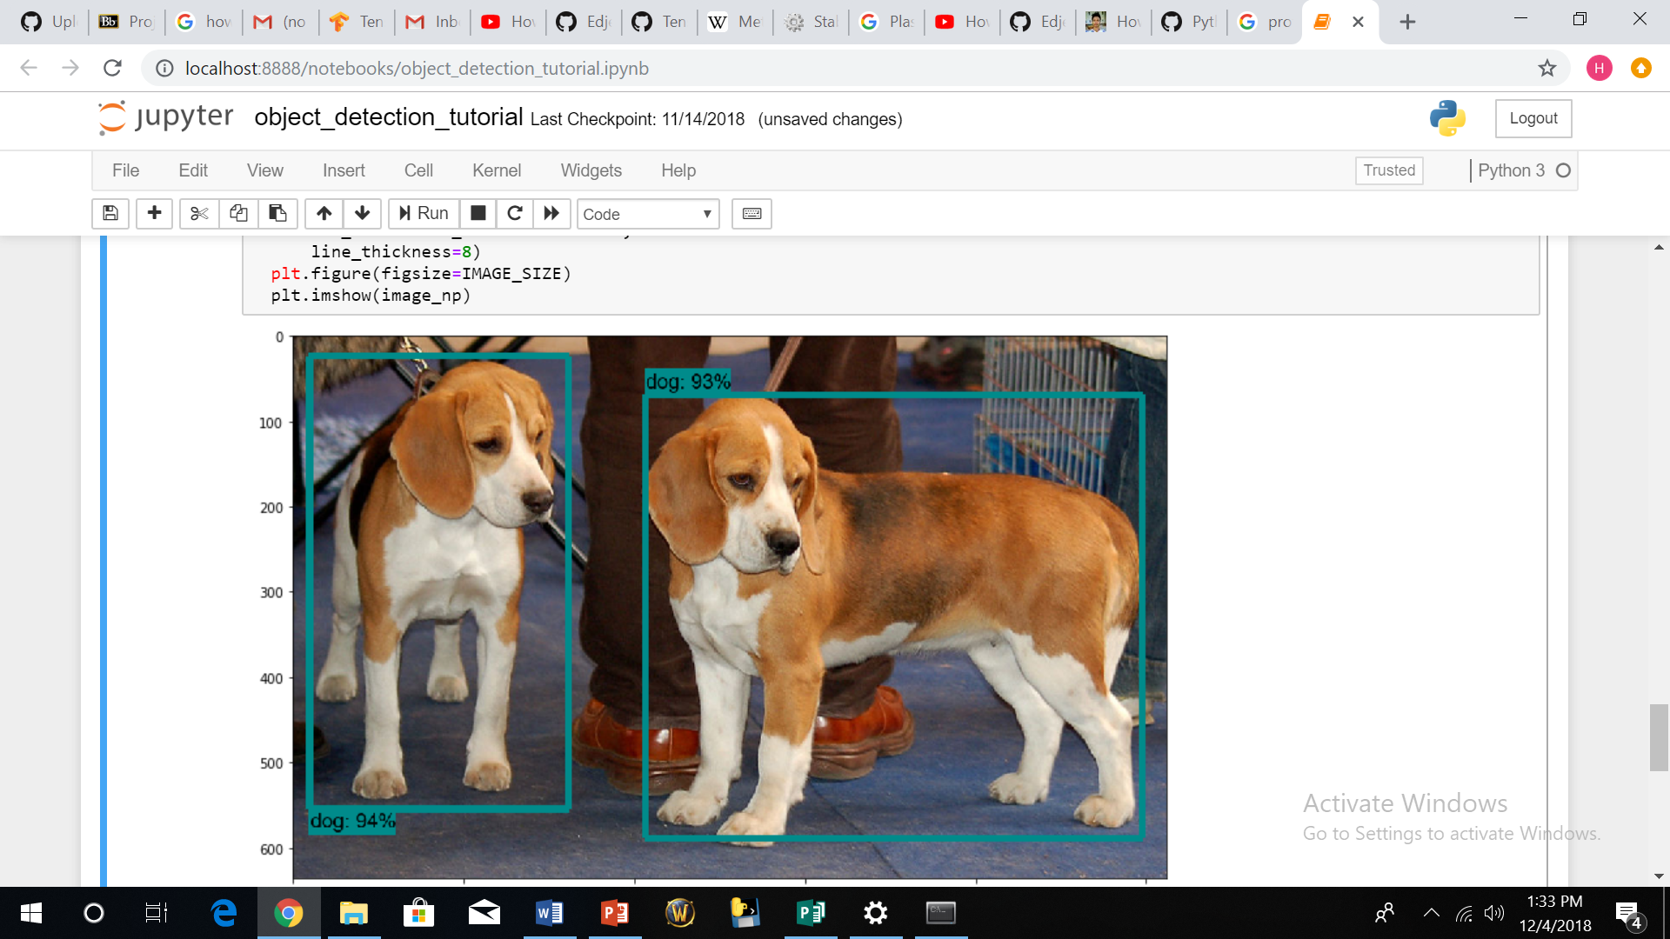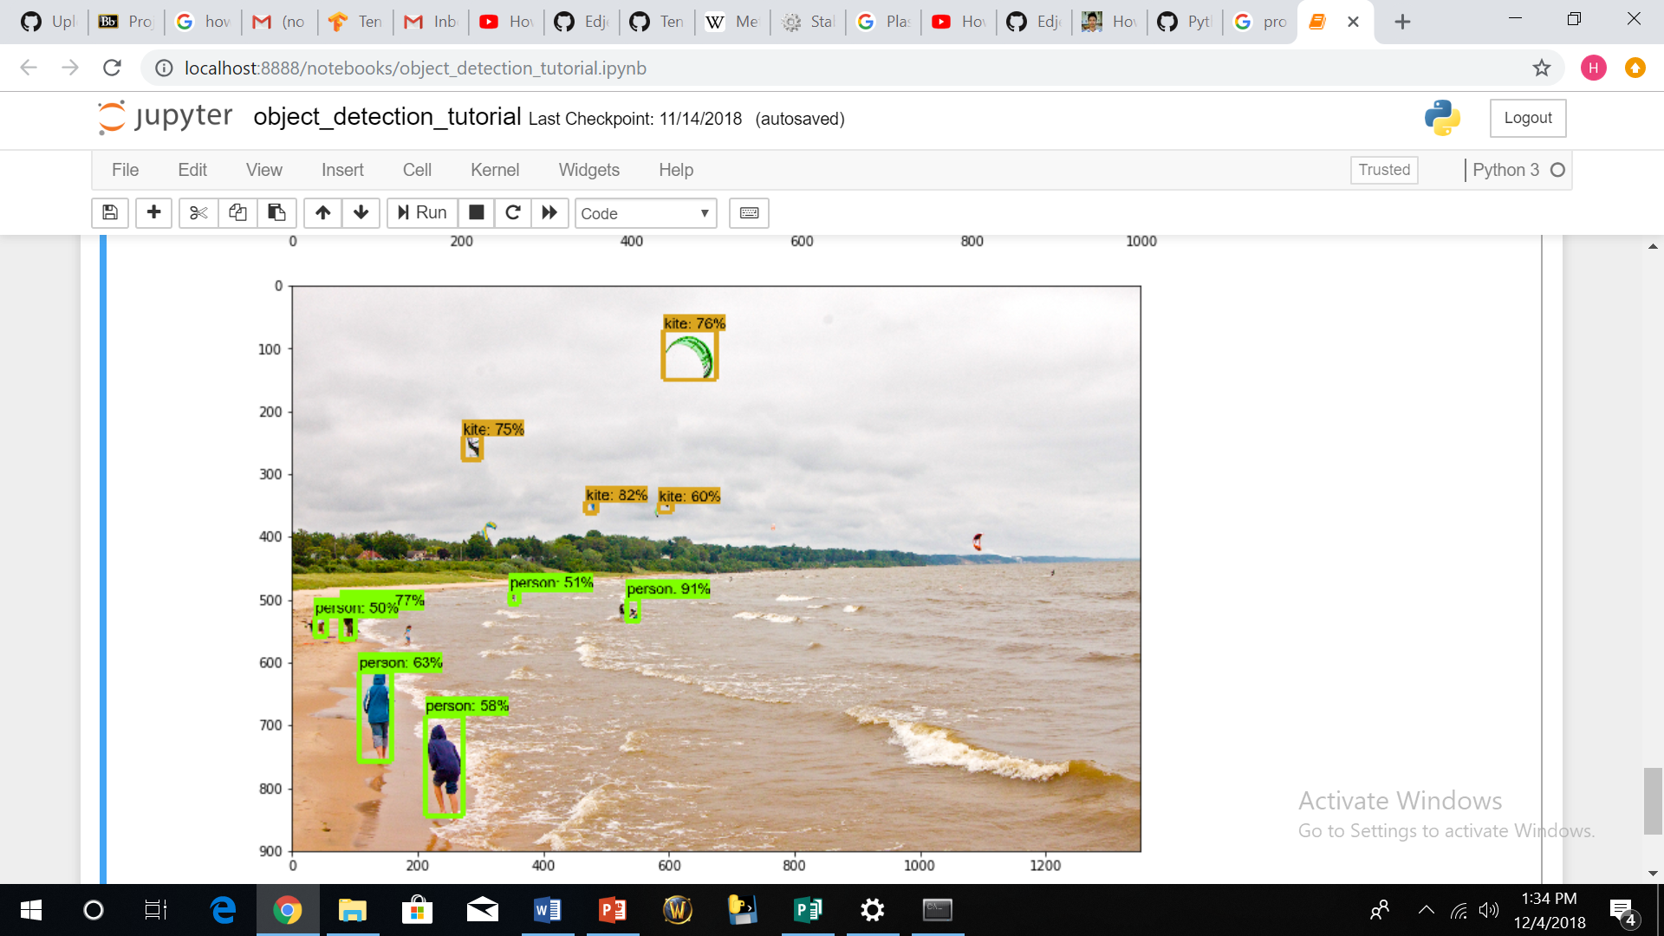

Figure 75 jypiter script tensorflow active

When running the script I had to change the condition of the code from tensorflow < 1.8 to tensorflow < 1.4 for it to run and above was the result. That shows the setup is ready for training.

1. Gathering and labelling pictures

I took about 245 pictures in different terrain and lighting condition then divided them into 2. I had 20 percent of them in the testing folder and the rest in the training folder. The more diverse the pictures are the more efficient the model will be in recognizing the object

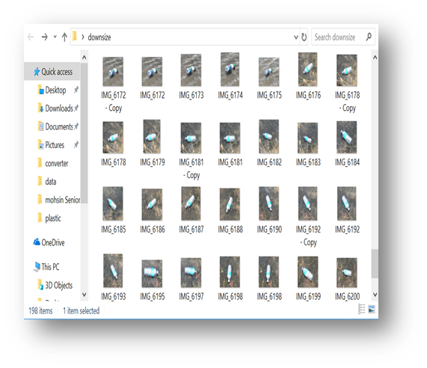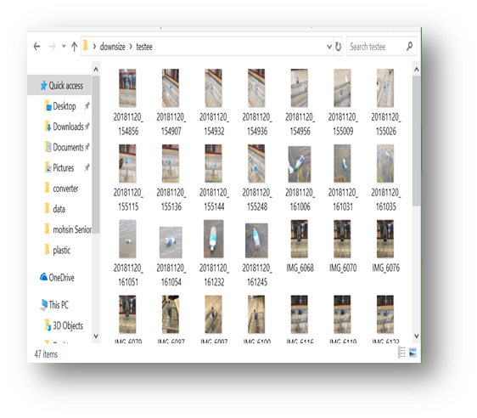

Figure 76 dataset

Using the llabelmg software, I was able to label the pictures and generate the xml files which contains the co-ordinate values of all the pictures.

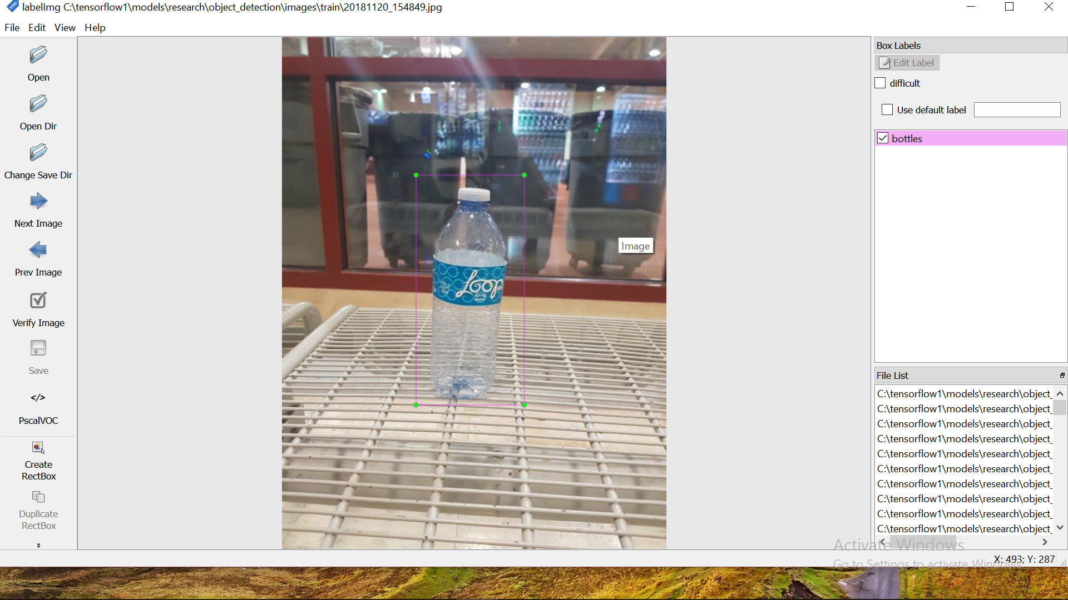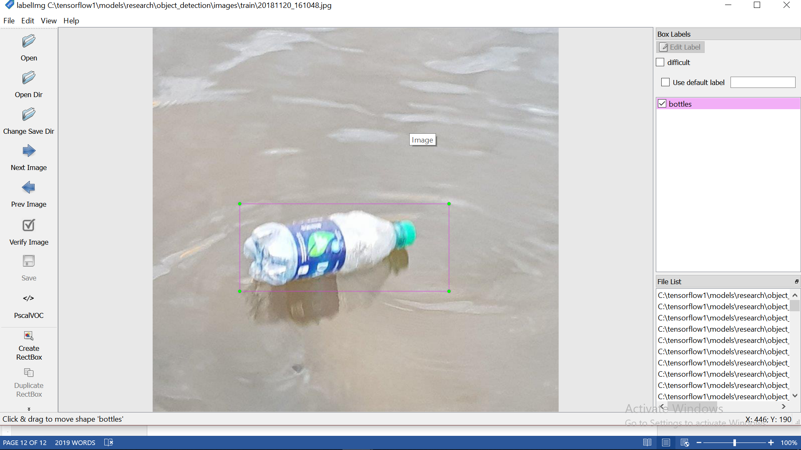

Figure 77 image labelling

1. Generate training data

(tensorflow1) C:\tensorflow1\models\research\object_detection> python xml_to_csv.py

After running that, csv file is generated in the object detection folder

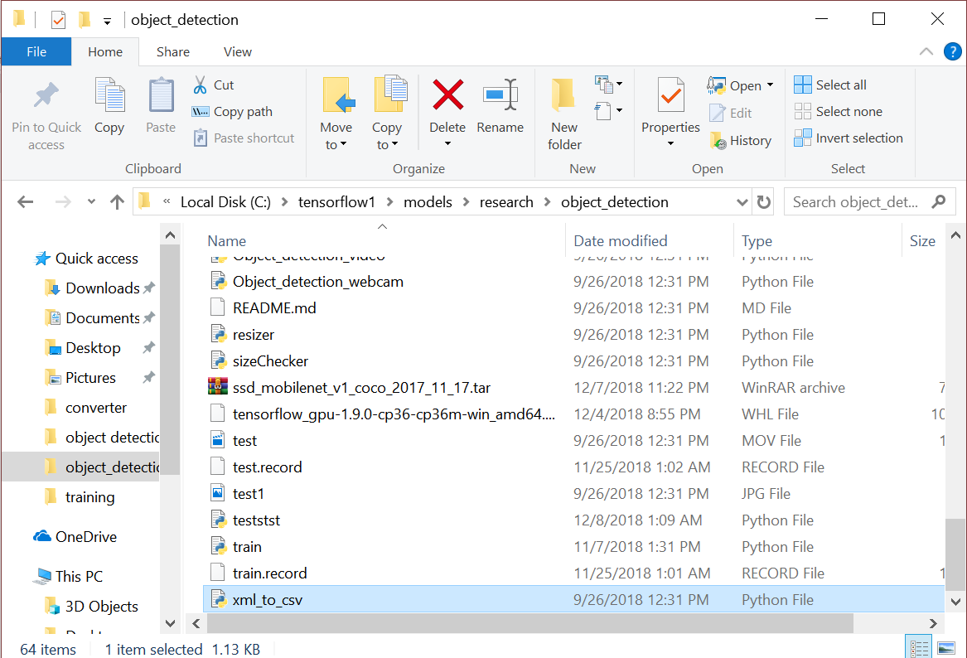

Figure 78 file generated

1. Create Label Map and Configure Training

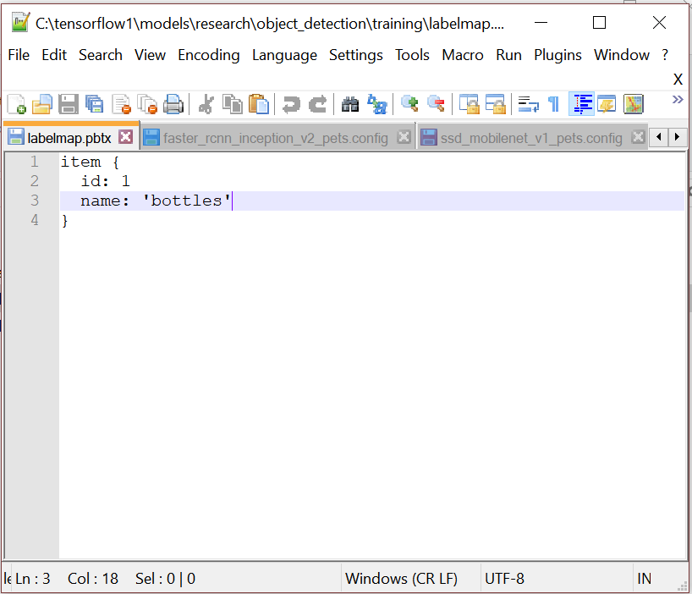

Figure 79 label map

The labelmap.pbtx must be saved in the training folder.

1. Run the training

Run the code

python.pylogtostderrtrain_dir=training/pipeline_config_path=training/ssd_mobilenet_v1_pets.config

The training commenced

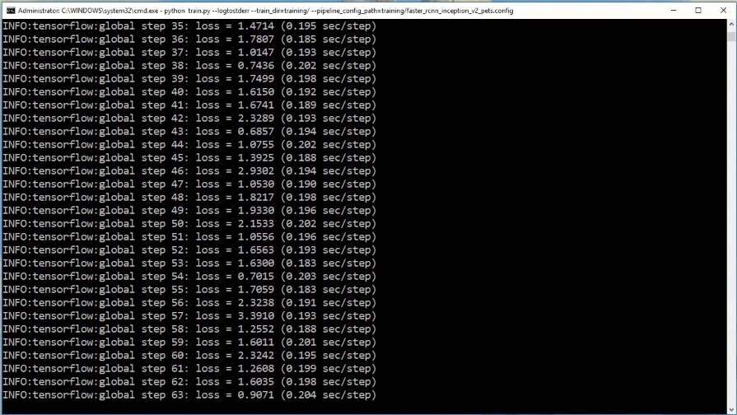

Figure 80 training interface

After getting a very low error, quit the process and generate an inference graph.

1. Export the inference graph

python export_inference_graph.py --input_type image_tensor --pipeline_config_path training/ ssd_mobilenet_v1_pets.config--trained_checkpoint_prefixtraining/model.ckpt-1--output_directory inference_graph

This creates a frozen_inference_graph.pb file in the \object_detection\inference_graph folder. The .pb file contains the object detection classifier

This frozen inference graph is uploaded into the raspberry pi and tested.

Result

After upload the trained cnn into the raspberry pi, we tested it by going into the objected detection folder and running the code below.

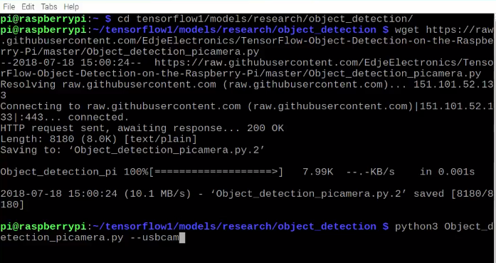

Figure 81 image recognition start up interface

Enter pressing enter, the web cam comes on and within seconds, the video is shown on the screen. Below are the results obtained.

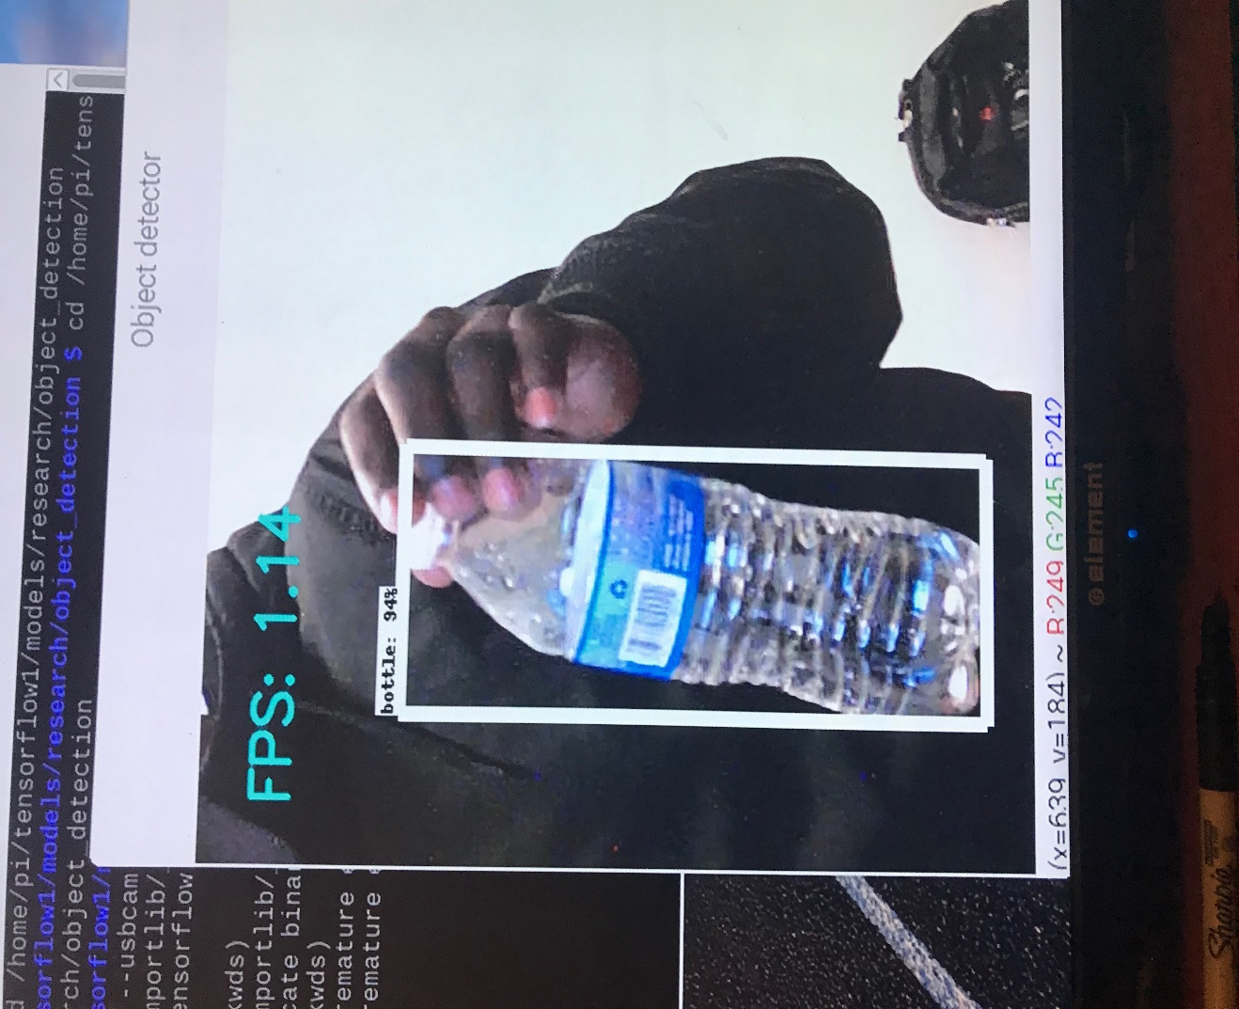

Figure 82 successful trial 1

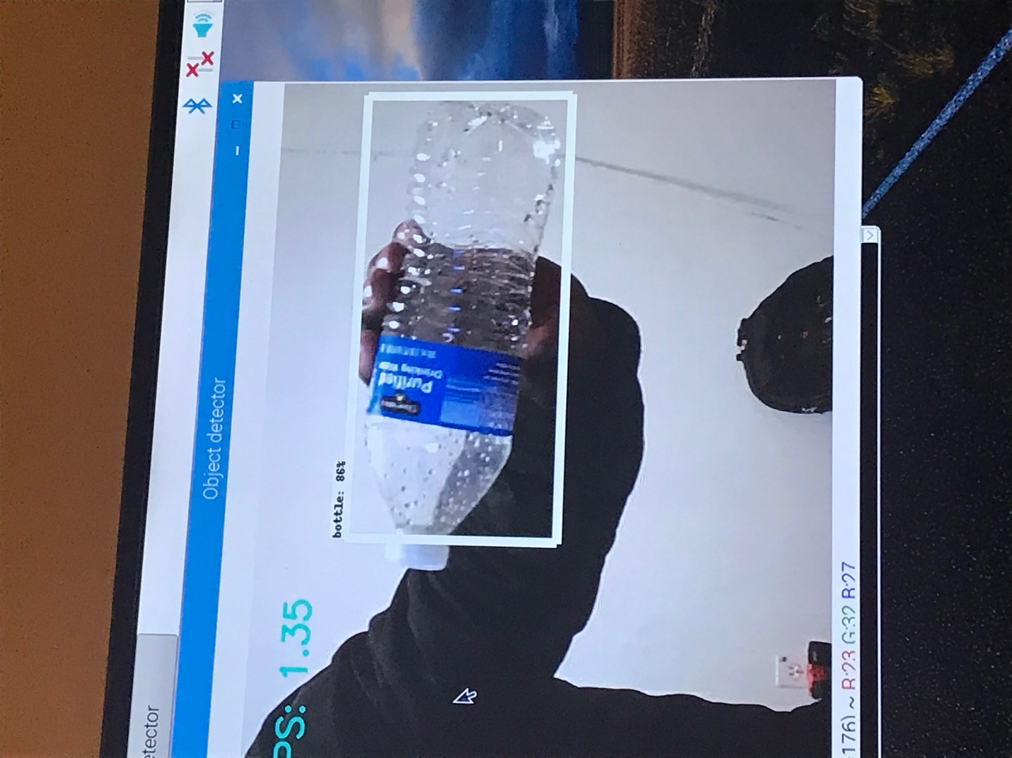

Figure 83 successful trial 2

These are 2 pictures out of all the testing carried out. A frame rate of 1.35 and 1.14 was achieved with 94% and 86% successfully.

Runtime for image recognition unit

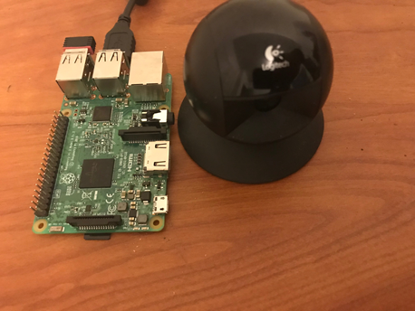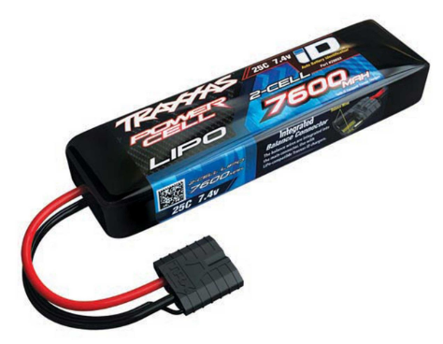

Figure 84 2s battery Figure 85 image recognition set up

The images recognition unit includes a raspberry pi3, a webcam and 2-cell 7600mAh battery. Since the raspberry pi requires a 5v and 2.25A to operate, a ubec must be introduced to help regulate the voltage 7.4v coming out of the battery.

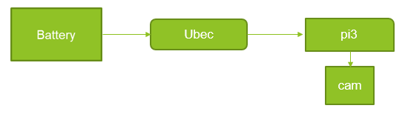

Figure 86 power connection layout for raspberry pi

Therefore, the runtime for the image recognition unit will be 7.4Ahr / 2.25A =3hr 17mins.

## Implementation of task 9.

Research on pixhawk/ autonomy.

Implementing autonomy is one of our primary objective in this project and in other to achieve that, we have use the pixhawk. A pixhawk is a high-performance autopilot-on-module suitable for fixed wing, multi rotors, helicopters, cars, boats and any other robotic platform that can move. It is targeted towards high-end research, amateur and industry needs and combines the functionality of the PX4FMU + PX4IO. It is a further evolution of the PX4 flight controller system. Pixhawk consists of a PX4-FMU controller and a PX4-IO integrated on a single board with additional IO, Memory and other features.

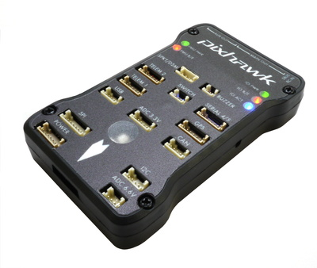

Figure 87 pixhawk

Step1: install the mission planner

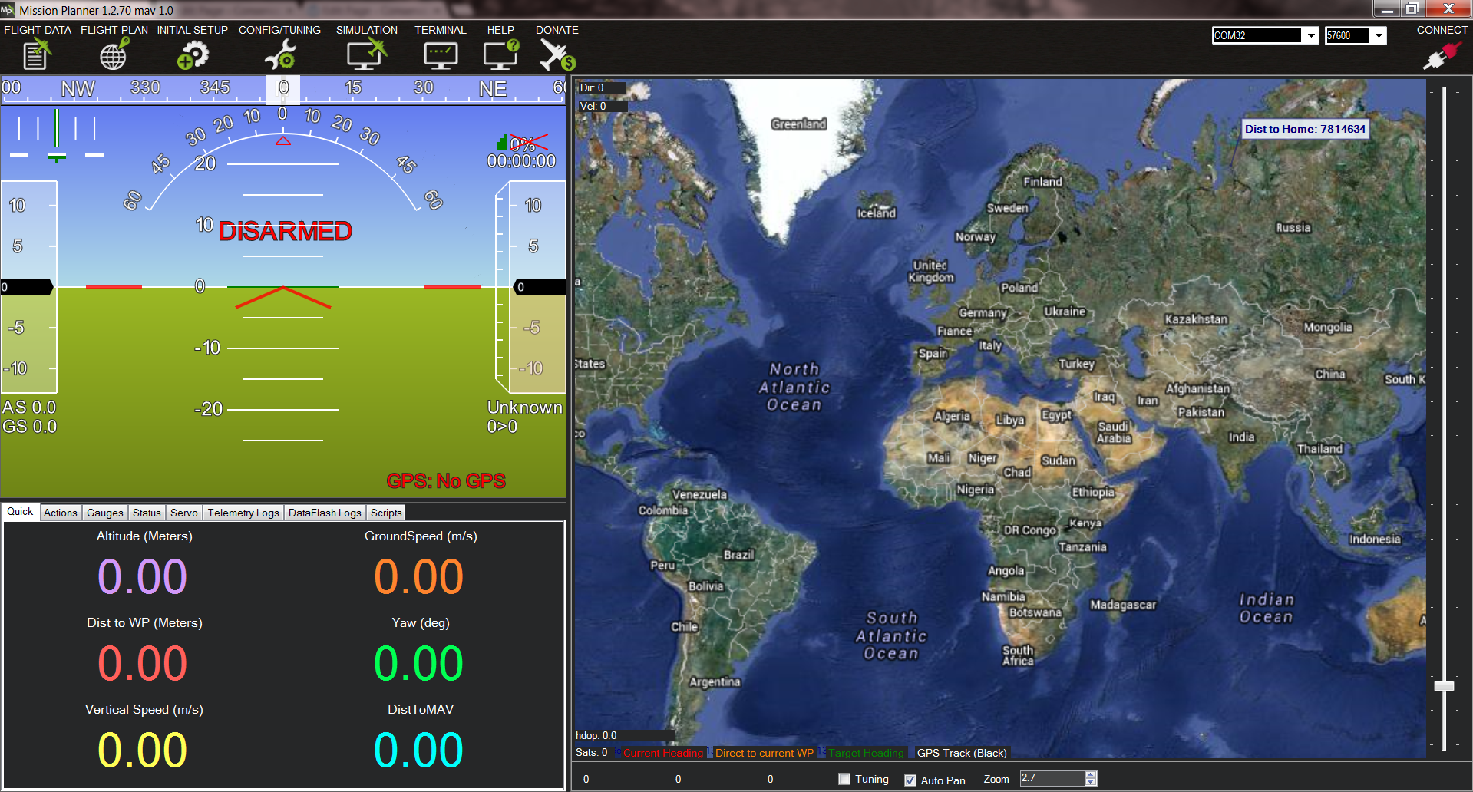

Figure 88 mission planner interface

The figure above shows the interface of the mission planner software on the computer. Mission Planner is a full-featured ground station application for the ArduPilot open source autopilot project. Mission Planner is a ground control station for Plane, Copter and Rover. It is compatible with Windows only. Mission Planner can be used as a configuration utility or as a dynamic control supplement in our autonomous vessel.

Step2: Connect the pixhawk to the mission planner.

[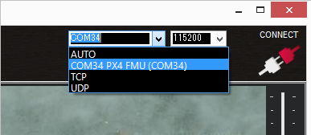](http://ardupilot.org/rover/_images/Pixhawk_ConnectWithMP.png)

Figure 89 connection to mission planner through port

To connect the 2 together, open the Mission Planner and select the COM port drop-down on the upper-right corner of the screen (near the Connect button). Select AUTO or right COM in Mission Planner board (PX4 FMU or Arduino Mega 2560). Set the Baud rate to 115200 as shown. Don’t hit Connect just yet. Click the correct COM port as shown below.

Step 3: Download and install ardurover onto the Pixhawk

Although we are working on a water vessel we need to work with the rover configuration and try as much as possible to manipulate it to requirement. On the Mission Planner’s Initial Setup |Install the Firmware screen and select the appropriate icon that matches the frame. For this case it will be the rover selected. Answer yes when it asks “Are you sure?” Below shows the different selections the user can choose which the image of the car is chosen since it’s the Ardurover.

[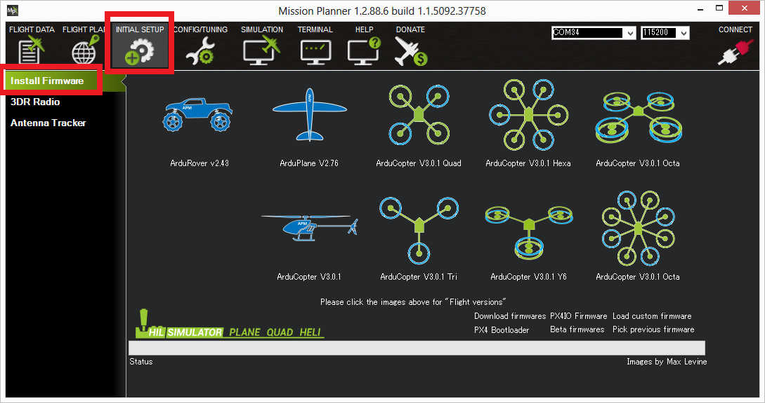](http://ardupilot.org/rover/_images/Pixhawk_InstallFirmware.jpg)

Figure 90 Select the right firmware

For navigation, certain changes must be made to adapt the rover setting for a water vessel. The throttle setting for motion is the same in both cases but the servo used for changing the rover will be used to control the servo connected to the rudder. But we must take not of the difference in the direction and set the rudder accordingly since its reverse when compared to the rover.

For separate steering and throttle vehicles these parameters values should be set (they should actually be set by default):

SERVO1_FUNCTION = 26 (GroundSteering)

SERVO3_FUNCTION = 70 (Throttle)

If using the mission planner, the Initial Setup >> Mandatory Hardware >> Servo Output page is a convenient way to do this

[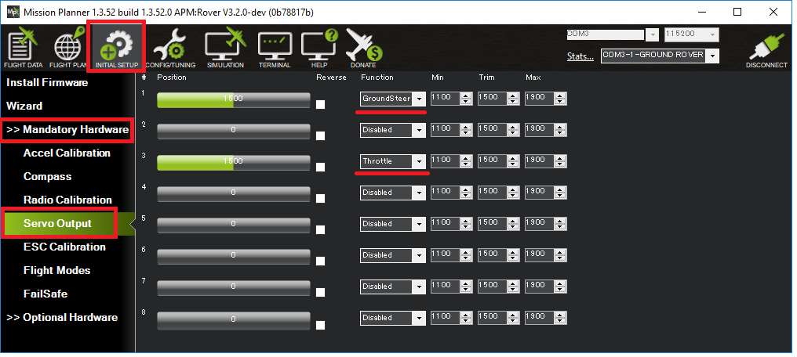](http://ardupilot.org/rover/_images/rover-motor-and-servo-config1.png)

Figure 91 motor and servo control set up

Due to the difference in terrain, autonomous navigation is more challenging because of physical factors such as tide, wind therefore the PID tuning in important in maintaining balanced movement and staying on course. Recently new improvement have been made to the autonomous sailing technology, new features have been introduced.

The special features for Boats include:

* Boats appear as boats on the ground station (version 3.3.0 and higher)
* In Auto, Guided, RTL and SmartRTL modes the vehicle will attempt to maintain its position even after it reaches its destination (version 3.2.0 and higher)
* Vectored Thrust can be enabled to improve steering response on boats which use the steering servo to aim the motors (version 3.3.1 and higher)
* Loiter mode for holding position
* Echosounders for underwater mapping.

Layout of the navigation system

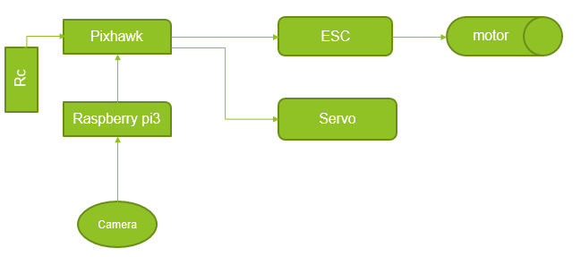

Figure 92 navigation layout

In the above layout, the pixhawk is the primary navigating micro controller. We have a receiver connected to allow the user take control manually at any point in time. Raspberry pi is able to communicate with the pixhawk using the MAV link protocol over a serial port connection. When an object has been directed, the raspberry pi sends signals to the pixhawk through the RX & TX ports and guides it to the object depending on the X and Y coordinates that tells how far left or right the object is and the pixhawk in turn interrupts its mission for collection. After the target has been acquired, the pixhawk goes back to its mission and the raspberry pi continues its search.

Runtime of the navigation system

Two 2-cell batteries will be used for the setup. Using 2 batteries enable managing weight distribution, it makes it easier to troubleshoot if problem arises and it’s more affordable. 1 battery is used to power the motor and the other is used for the micro controllers.

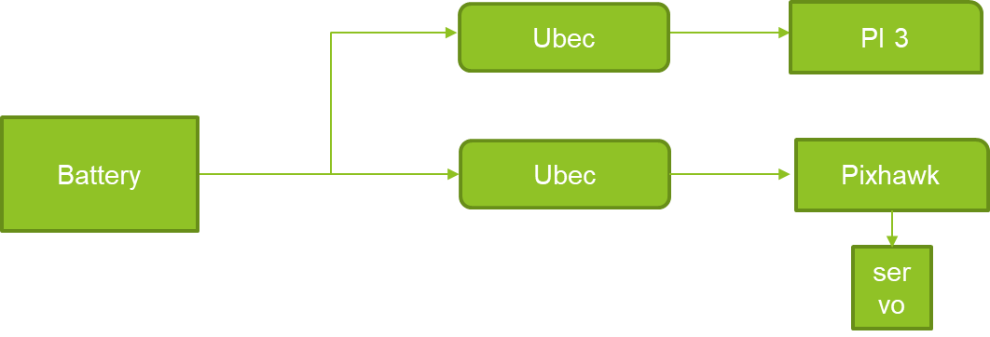

Figure 93 power connection for microcontrollers

* The battery is connected in parallel to 2 ubec which is connected to the raspberry pi and pixhawk
* The current required by the microcontroller are 2.5 and 2.25
* Total current drawn = 4.75 A
* Battery amp per hour rating = 7600mAh
* Operation time: 7.6Ah / 4.75A = 1.6
* Which is 1hr 36 mins

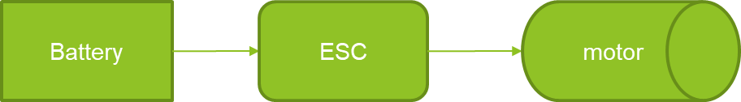

Figure 94 power connection for motors

* Current required for the operation of the motor = 10A
* Battery amp per hour rating = 7600mAH
* Operation time: 7.6/10 = 0.76 hours
* 0.76 * 60 = 45.6 mins

## Implementation of task 10.

1. Conclusion.

By the end of the project, conclude the project and your learning experience.

Acknowledgement

If you get help or support from someone else (besides the team member and the advisor) and want to show your appreciation, put here (do not include the advisor).

Appendix

You can put reference info here, including: i) specs of components used in the system, ii) source code (must be here but not in the body text), iii) CAD figures, etc.

1. Component Specs
2. Specs of Arduino Due

...

1. Raspberry Pi 3

…

1. Source Code.
2. Source Code of Graphic User Interface

…

1. Source Code of Robotic Arm

…

REFERENCES

[1] Evans, R. C. (n. d.). *How a sail boat sails into the wind*. Retrieved from

http://web.mit.edu/2.972/www/reports/sail_boat/sail_boat.html

Marsh, M. B. (2012). *Understanding monohull sailboat stability curves*. Retrieved from

http://marine.marsh-design.com/content/understanding-monohull-sailboat-stability-curves

D. Vantrease, R. Schreiber, M. Monchiero, M. McLaren, N. P. Jouppi, M. Fiorentino*, et al.*, "Corona: System Implications of Emerging Nanophotonic Technology," in *Computer Architecture, 2008. ISCA '08. 35th International Symposium on*, 2008, pp. 153-164.

[2] X. Zhang and A. Louri, "A multilayer nanophotonic interconnection network for on-chip many-core communications," in *Design Automation Conference (DAC), 2010 47th ACM/IEEE*, 2010, pp. 156-161.

[3] C. Batten, A. Joshi, J. Orcutt, A. Khilo, B. Moss, C. Holzwarth*, et al.*, "Building manycore processor-to-DRAM networks with monolithic silicon photonics," in *High Performance Interconnects, 2008. HOTI '08. 16th IEEE Symposium on*, 2008, pp. 21-30.

[4] Y. Pan, P. Kumar, J. Kim, G. Memik, Y. Zhang, and A. Choudhary, "Firefly: illuminating future network-on-chip with nanophotonics," in *IEEE/ACM Intl. Symp. on Computer Architecture (ISCA)*, 2009, pp. 429-440.

[5] N. Kirman, M. Kirman, R. K. Dokania, J. F. Martinez, A. B. Apsel, M. A. Watkins*, et al.*, "Leveraging Optical Technology in Future Bus-based Chip Multiprocessors," in *Microarchitecture, 2006. MICRO-39. 39th Annual IEEE/ACM International Symposium on*, 2006, pp. 492-503.

[6] J. M. Cianchetti, C. J. Kerekes, and H. D. Albonesi, "Phastlane: a rapid transit optical routing network," in *Proceeding of: 36th International Symposium on Computer Architecture (ISCA)*, 2009, pp. 441-450.

[7] A. Shacham, K. Bergman, and L. P. Carloni, "Photonic Networks-on-Chip for Future Generations of Chip Multiprocessors," *Computers, IEEE Transactions on,* vol. 57, pp. 1246-1260, 2008.

[8] A. Shacham, K. Bergman, and L. P. Carloni, "On the Design of a Photonic Network-on-Chip," in *First International Symposium on Networks-on-Chip, 2007. NOCS 2007*, 2007, pp. 53-64.

[9] M. Kwai Hung, Y. Yaoyao, W. Xiaowen, Z. Wei, L. Weichen, and X. Jiang, "A Hierarchical Hybrid Optical-Electronic Network-on-Chip," in *VLSI (ISVLSI), 2010 IEEE Computer Society Annual Symposium on*, 2010, pp. 327-332.

[10] D. Ding and D. Z. Pan, "OIL: a nano-photonics optical interconnect library for a new photonic networks-on-chip architecture," presented at the Proceedings of the 11th international workshop on System level interconnect prediction, San Francisco, CA, USA, 2009.

[11] A. Joshi, C. Batten, K. Yong-Jin, S. Beamer, I. Shamim, K. Asanovic*, et al.*, "Silicon-photonic clos networks for global on-chip communication," in *Networks-on-Chip, 2009. NoCS 2009. 3rd ACM/IEEE International Symposium on*, 2009, pp. 124-133.

[12] D. Vantrease, R. Schreiber, M. Monchiero, M. McLaren, N. P. Jouppi, M. Fiorentino*, et al.*, "Corona: system implications of emerging nanophotonic technology," in *Proc. 35th IEEE/ACM Int'l Symp. Computer Architecture (ISCA)*, 2008, pp. 153-164.

[13] L. Zhang, E. Regentova, and X. Tan, "A 2D-Torus Based Packet Switching Optical Network-on-Chip Architecture," presented at the *IEEE International Symposium on Photonics and Optoelectronics* (SOPO 2011), Wuhan, China, 2011.

[14] L. Zhang, E. E. Regentova, and X. Tan, "Packet switching optical network-on-chip architectures," *Comput. Electr. Eng.,* vol. 39, pp. 697-714, 2013.

[15] G. Huaxi, X. Jiang, and W. Zheng, "A novel optical mesh network-on-chip for gigascale systems-on-chip," in *Circuits and Systems, 2008. APCCAS 2008. IEEE Asia Pacific Conference on*, 2008, pp. 1728-1731.

[16] G. Huaxi, X. Jiang, and Z. Wei, "A low-power fat tree-based optical Network-On-Chip for multiprocessor system-on-chip," in *Design, Automation & Test in Europe Conference & Exhibition, 2009. DATE '09.*, 2009, pp. 3-8.

[17] Y. Yaoyao, X. Jiang, H. Baihan, W. Xiaowen, Z. Wei, W. Xuan*, et al.*, "3-D Mesh-Based Optical Network-on-Chip for Multiprocessor System-on-Chip," *Computer-Aided Design of Integrated Circuits and Systems, IEEE Transactions on,* vol. 32, pp. 584-596, 2013.

[18] A. Shacham, K. Bergman, and L. P. Carloni, "Photonic networks-on-chip for future generations of chip multiprocessors," *IEEE Trans. Computers,* vol. 57, pp. 1246-1260, 2008.

[19] A. W. Poon, F. X. Xu, and X. Luo, "Cascaded active silicon microresonator array cross-connect circuits for WDM networks-on-chip," in *Proc. SPIE*, 2008, p. 689812.

[20] M. Lipson, "Compact Electro-Optic Modulators on a Silicon Chip," *IEEE Journal of Selected Topics in Quantum Electronics,* vol. 12, pp. 1520-1526, 2006.

[21] M. Lipson, "Guiding, modulating, and emitting light on Silicon-challenges and opportunities," *Lightwave Technology, Journal of,* vol. 23, pp. 4222-4238, 2005.

[22] T. Xianfang, Y. Mei, Z. Lei, J. Yingtao, and Y. Jianyi, "Wavelength-routed optical networks-on-chip built with comb switches," in *Photonics Conference (IPC), 2013 IEEE*, 2013, pp. 46-47.